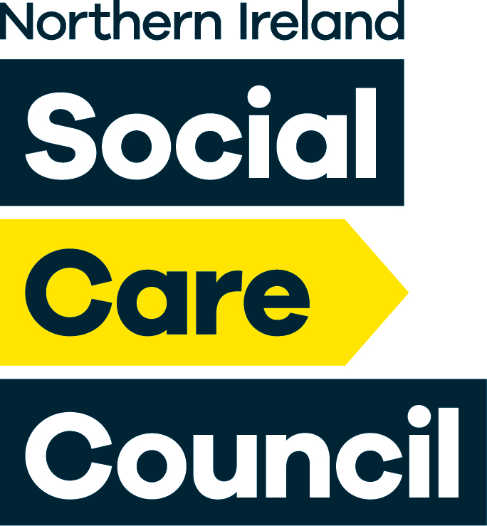 Draft
Social Care Council Board Meeting
10.00a.m – 1.00p.m on Wednesday 21st April 2021
Via Zoom link: https://us02web.zoom.us/j/87342711431
Listing |  | Agenda Item | Time | Presented by | Outcomes
Formalities
1. |  | Welcome and Apologies | 10am to 10:15am | Chairperson | For Noting
2. |  | Declarations of Interest |  | Chairperson | For Noting
3. |  | Business Focus –  “One Year on in Lockdown” |  | Video | For Information
4. |  | Minutes and Matters Arising from the previous meeting 9th December 2021 |  | Chairperson | Minutes  For Approval
Business Briefings
5. |  | Chair’s Report | 10:15am to  11:15 am | Chairperson | For Information
6. |  | Interim Chief Executive’s Report |  | Interim Chief Executive | Paper A  For Information
7. |  | Sub Committee Minutes
7.1 |  | Registrants Forum unconfirmed minutes of 7th December 2020 |  | Sub Committee Chair | For approval
7.2 |  | Participation Partnership unconfirmed minutes of 5th January 2021 |  | Sub Committee Chair | For approval
7.3 |  | Professional In Practice unconfirmed minutes of 24th February 2021 |  | Sub Committee Chair | For approval
7.4 |  | Leaders in Social Care Partnership draft unconfirmed minutes of 9th March 2021 |  | Sub Committee Chair | For approval
7.5 |  | Audit & Risk Assurance Committee unconfirmed Minutes of 27th January 2021 |  | Sub Committee Chair | For approval
15 min Break
Business Matters
Decision Papers |  |  | 11:30 am to 12:45pm
8. | COVID-19 Assurance Report including Business Continuity: Supplementary Plan in Managing a Pandemic |  |  | Declan McAllister | For approval
9. | Business Performance Report Quarter 4 to 31st March 2021 |  |  | Declan McAllister and Marian O’Rourke | For approval
10. | Finance Performance Report to 31st March 2021 |  |  | Declan McAllister | Paper to follow  For approval
11. | Draft Business Plan 2021 - 22 |  |  | Declan McAllister and Marian O’Rourke | For approval
12. | Corporate Strategy – Next Steps |  |  | Declan McAllister | For approval
13. | Board Self-Assessment |  |  | Chairperson | For approval
Review Papers
14. | Draft Annual Report 2021/22 – paper to follow |  |  | Declan McAllister and Marian O’Rourke | For review
Information Papers/update
15. | Supporting and Empowering our staff – 2021/22 – verbal update |  |  | Marian O’Rourke | For Information
Closing Formalities
16. | Any Other Business
17. | Dates of next meetings
17.1 | Board Strategic Session – 2.00p.m Wednesday 19th May  Board meeting – 10.00a.m Wednesday 30th June

