Muckamore Abbey Hospital Public Inquiry Consultation
About this document
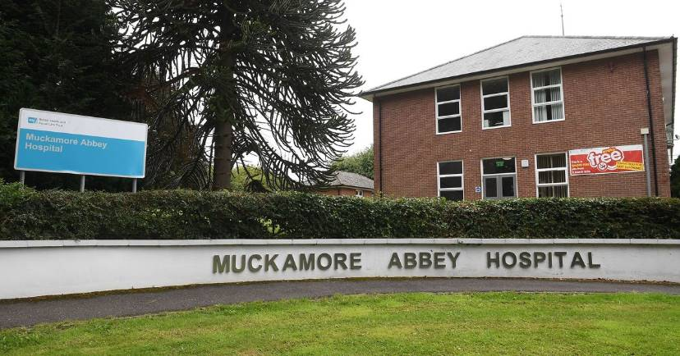 | This document is for people who were patients in Muckamore Abbey Hospital and the people who support them.
 | We wrote some important words in larger, darker, print. We explain what these words mean.
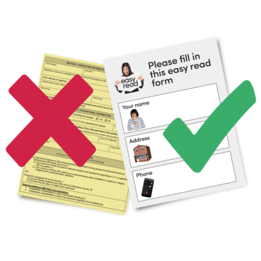 | This Easy to Read document explains a flyer that was sent to service providers and community groups.
 | We will send a more detailed guide about Public Inquiries soon.
 | A friend, family member, or support person may be able to help you read or understand this document.
 | This document is written in an Easy to Read way. We use pictures to explain some things.
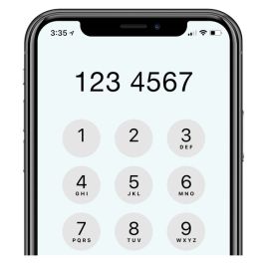 | If you need more help to understand this document, please phone Eleanor Good on 028 95361708. Eleanor works at the Patient and Client Council and is happy to help you.

Why did we send this document?
 | The Minister of Health, Robin Swann, has called for Public Inquiry into abuse at Muckamore Abbey Hospital.
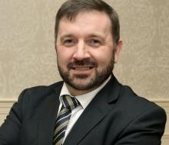 | Robin Swann is the Minister of Health for Northern Ireland. He makes policies that decide what is allowed to happen in care homes, hospitals, and other health care services.
 | A Public Inquiry is a legal investigation, similar to a trial. When something goes wrong, a Public Inquiry will try to find out what happened, why it happened, and what can be done to stop it from happening again.
 | Abuse is when someone hurts you or treats you badly.
 | The Minister of Health called a Public Inquiry because many people said they were abused in Muckamore Abbey Hospital.
 | Before the Public Inquiry starts, the Minister of Health wants to hear what patients think the Inquiry should investigate.
 | He asked the Patient and Client Council to talk to patients and their loved ones to find out.
 | The Patient and Client Council helps people explain their views about health and social care services.
 | We want listen to your experience in Muckamore Abbey Hospital.
 | You can talk to someone from the PCC on a one-to-one basis
 | Or in a group with other patients
 | If you want, you can ask someone you trust to help you talk to us.
 | Your story will help us decide what the Public Inquiry should investigate.

What next?
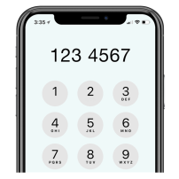 | If you want to talk to us or if you want more information, please phone Eleanor Good from the Patient and Client Council on 028 9536 1708
You can also send an email to Eleanor at
Eleanor.Good@pcc-ni.net
 | Talking to us is optional. You do not have to do it, and you can tell us as much or as little as you would like.

