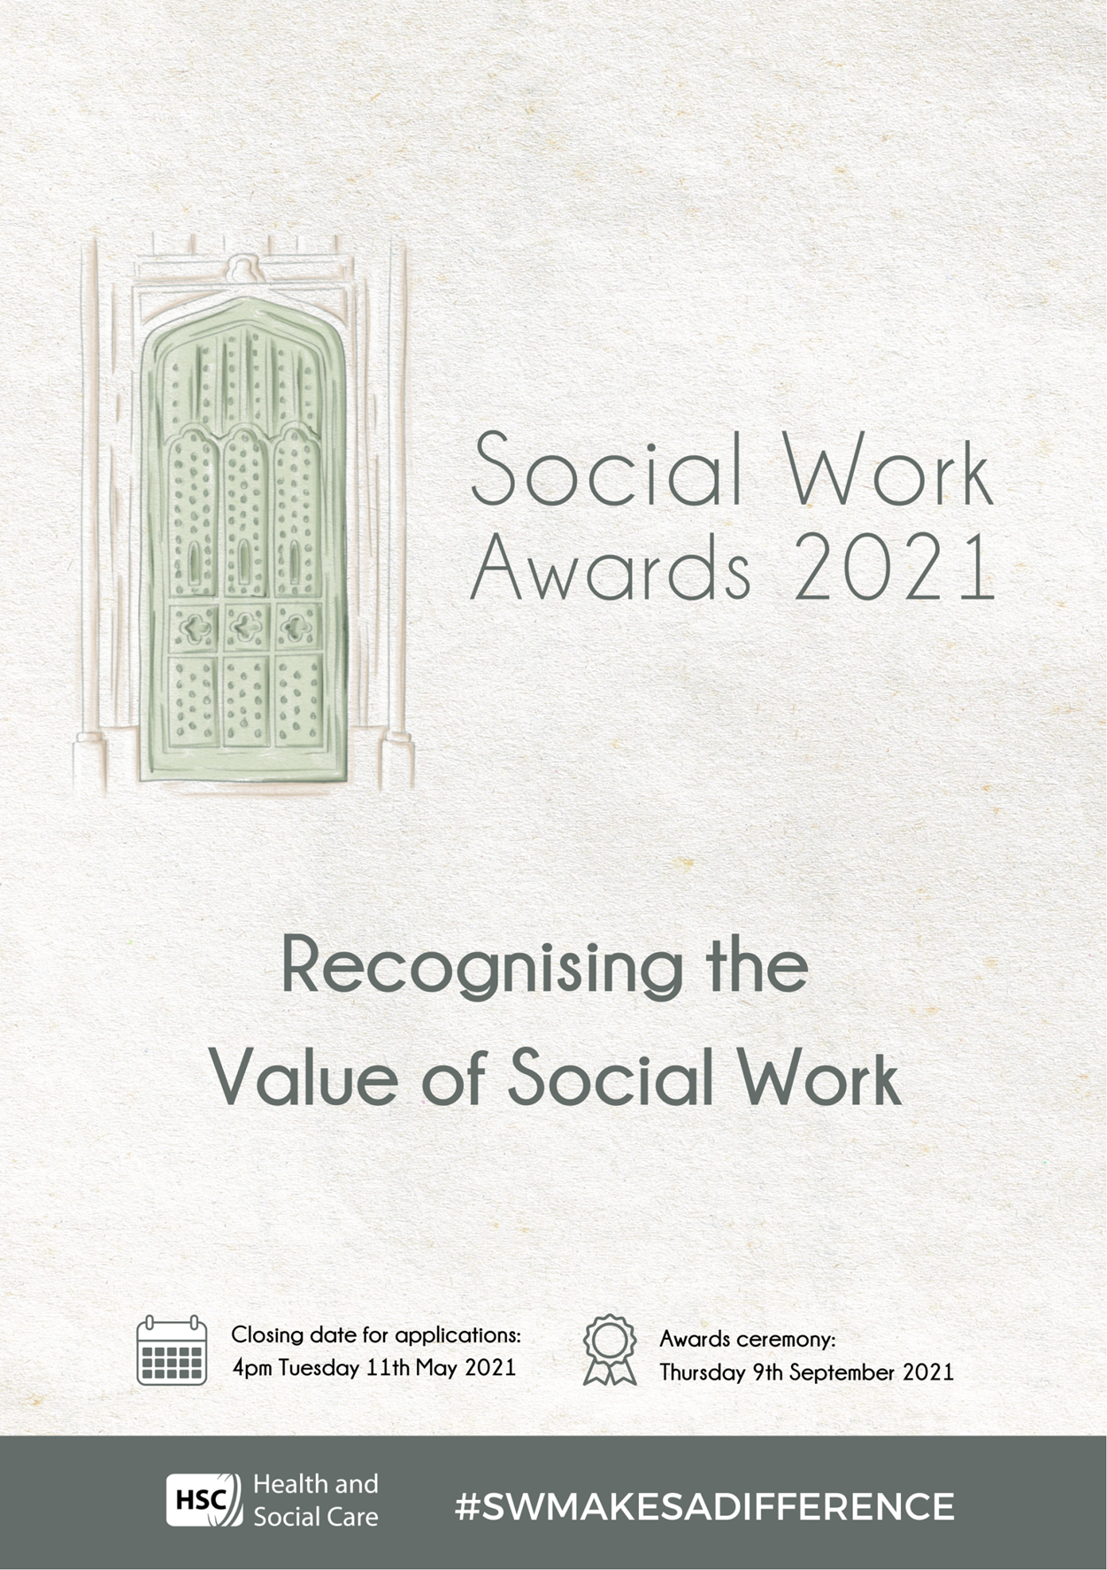

Contents

About the Social Work Awards 2
Who can enter? 3
What the judges are looking for 4
The Awards 5
How to enter 8
Entry information 9
Rules and conditions of entry 10
Entry Forms 11

About the Social Work Awards

Social work is about people who, for a variety of reasons, may need extra help and support to cope with everyday living. There are over 6,600 social workers practising in Northern Ireland. Twenty four hours a day, seven days a week, they are using their professional skills and knowledge to assess the needs of people of all ages and backgrounds; planning and implementing the care and support that allows them to live as independently and safely as possible.

Social workers often work with people in sensitive and difficult environments to help them make positive changes to their situation. This means that the media and the wider public rarely find out about the contribution social workers make to people and communities across Northern Ireland. Good news stories about social work rarely receive public or media attention, yet negative stories relating to social work make front page news and are often a matter of public discussion. The Social Work Awards are an opportunity to promote how social work makes a positive difference to people’s lives. This is an opportunity for social workers to promote and be proud of their profession.

- The Social Work Awards are to promote and celebrate excellence in social work.

- The Awards were introduced by the Raising the Profile Group, formed by the Health & Social Care Board to raise the profile of social work.

- There are eight Awards for 2021.

- The Awards are a public recognition of social workers’ achievements.

- Service Users, Carers or Employers who are nominating a Team or Individual will have the opportunity to acknowledge the positive contribution social workers have made for them.

- The seventh Social Work Awards will be held on Thursday 9th September 2021. The ceremony will be an in-person, virtual or blended event depending on Covid-19 regulations at the time

The sixth Social Work Awards were held in November 2019. They were a great success with 100 applications from across all sectors and all parts of Northern Ireland. The 2019 winners were:

Children’s Services (Team Award): Edge of Care Service (BHSCT)

Adult Services (Team Award): Aspire Young Men’s Project (PBNI)

Co-production (Team Award): Co-production Interns (SEHSCT)

Learning and Development (Team Award): Children’s Early Intervention Service (NHSCT)

Learning and Development (Individual Award): Marita Magennis (SHSCT)

Social Worker of the Year (Individual Award): Mal Byrne (Extern)

Newly Qualified Social Worker (Individual Award): Ryan Maguire (SEHSCT)

NIASW Lifetime Achievement Award: Liz Stevenson (SHSCT)

Who can enter?

The Awards are open to social workers and teams working in the statutory, voluntary, private, education and training sectors in Northern Ireland. Applications are welcome from all areas of social work; you do not have to be working in a unique project to submit an application. Teams and individuals working in core social work teams/posts are encouraged to apply. The BASW NI Lifetime Achievement Award is open to social workers in the service or who have retired. Previous applicants are welcome to reapply if their application has a different practice focus. Please read all of the information in this booklet before you complete and send in your entry.

You can download a Word version of this information pack with entry forms from www.niscc.info. Completed entry forms must be emailed as a Word document by the endorser (or proposer of the Lifetime Achievement Award) to the Social Care Council at jordan.adair@niscc.hscni.net by 4pm on Tuesday 11 May 2021.
What the judges are looking for
Seven awards will be presented for excellence, along with a Lifetime Achievement Award, sponsored by the British Association of Social Workers, Northern Ireland.

- Children Services Team of the Year
- Adult Services Team of the Year
- Coproduction Award of the Year sponsored by the Social Work Strategy Department of Health
- Learning and Development Award of the Year
- Children Services Social Worker of the Year
- Adult Services Social Worker of the Year
- Newly Qualified Social Worker of the Year
- Lifetime Achievement Award sponsored by the British Association of Social Workers Northern Ireland

All entries must show how the work is involving and benefiting people who use social work services. Applications must demonstrate the unique contribution that social work has made to their work, team, service users or carers.

Entries are invited from all types of social work services and can be from any social work setting or organisation in Northern Ireland.

The judging panels will be chaired by senior representatives responsible for promoting high standards of social work in Northern Ireland. Panel members will include service users, social work academics and members of the British Association of Social Workers, Northern Ireland.

The judges will be looking for evidence of the individual or team’s achievements. The application must demonstrate what is excellent about the social work practice and the positive impact on individuals, groups and communities.

The finalists will be invited to the Award ceremony on Thursday 9th September 2021. The ceremony will be an in-person, virtual or blended event depending on Covid-19 regulations at the time.

The Awards

- Children’s Services Team of the Year

For this Award the judges welcome entries from teams that can demonstrate how they are making a positive difference to the lives of children and families.

Submissions should demonstrate:
- The contribution the team makes to Children’s Services
- How the team puts children and families at the centre of their work
- Evidence of the benefits of the work to children and families
- Evidence of the quality and effectiveness of the team
- What makes this an award-winning team

Quotes/testimonies from service users/carers, other professionals strengthen a submission

- Adult Services Team of the Year

For this Award the judges welcome entries from teams that can demonstrate how they are making a positive difference to the lives of adults.

Submissions should demonstrate:
- The contribution the team makes to Adult Services
- How the team puts adult service users at the centre of their work
- Evidence of the benefits of the work to adult service users
- Evidence of the quality and effectiveness of the team
- What makes this an award-winning team

Quotes/testimonies from service users/carers, other professionals strengthen a submission

- Coproduction Award of the Year

Coproduction recognizes people’s capabilities and promotes enabling them to work with professionals and each other. For this Award the judges welcome entries from staff/teams who can evidence coproduction in practice.

Submissions should demonstrate:
- The vision and achievements of the coproduction project
- Provide evidence of valuing people and recognizing their contributions
- Service users/families making a real difference to improve our services
- Clear evidence of how coproduction is enabling and facilitating change
- What makes this an award winning entry

Quotes/testimonies from service users/carers, other professionals strengthen a submission
- Learning and Development Award of the Year

This Award is for individuals or teams who through education, learning and development make a difference to developing social work practice. This may include research, evidence based practice, practice learning, coaching and mentoring and direct training.

Submissions should demonstrate:

Team/Individual
- The contribution this team/individual makes to learning and development.
- How the team/individual puts learners at the centre of their work
- Evidence of the benefits of the work to social workers/social work students
- Evidence of the quality and effectiveness of the team/individual
- What makes this an award winning team/individual

Quotes/testimonies from social workers/ social work students, service users/ carers, other professionals strengthen a submission.

- Children Services Social Worker of the Year

This Award is for the individual social worker who provides a service that makes a difference to the lives of individuals, families and communities.

When nominating a social worker for this award, please outline what makes this social worker’s practice excellent. Please include examples of the contribution this social worker has made to children’s or adult service users lives. Quotes and testimonies from service users, carers and other professionals strengthen a submission.

- Adult Services Social Worker of the Year

This Award is for the individual social worker who provides a service that makes a difference to the lives of individuals, families and communities.

When nominating a social worker for this award, please outline what makes this social worker’s practice excellent. Please include examples of the contribution this social worker has made to children’s or adult service users lives. Quotes and testimonies from service users, carers and other professionals strengthen a submission.

- Newly Qualified Social Worker of the Year

This Award is for the newly qualified social worker who provides a service that makes a difference to the lives of individuals, families and communities.

To be eligible to apply for this Award the social worker must have successfully completed the Assessed Year in Employment (AYE) and be in the first two years of post-AYE social work employment .

When nominating a social worker for this award, please outline what makes this social worker’s practice excellent. Please include examples of the special contribution this social worker has made to people’s lives. Quotes and testimonies from service users, carers and other professionals strengthen a submission.

- BASW NI Lifetime Achievement Award

Do you work with or know an exceptional social worker? Would you like them to be recognized by the profession?

The BASW NI Lifetime Achievement Award was established to recognise those social workers who have worked consistently and steadfastly to improve social work services and/or practice in their field or area of expertise.

Their significant contribution may have been through leadership or promoting best practice in their area of social work expertise, demonstrating innovation in practice, contributing to research or education and training or being a published author or being recognised as an expert by colleagues due to a lifetime of professional experience.

Being a lifetime award, these social workers will have demonstrated leadership or innovation over a full social work career.

The BASW NI Lifetime Achievement Award is your opportunity to honour a colleague, by highlighting their hard work and commitment throughout their social work career. Social workers currently in the service and those who have retired from the service can be nominated for this Award.

Submissions should demonstrate:
- That the social worker has worked consistently and steadfastly to improve social work services and/or practice throughout their social work career
- That the social worker has made one or more outstanding contributions or a series of significant contributions, to advance, promote or improve social work practice and/or services and/or policy in Northern Ireland
- If possible, examples of the special lifetime contribution they have made should be included along with quotes/ testimonies from service users, carers and other professionals
How to enter

- The information pack and entry forms, can be downloaded from the Social Care Council website www.niscc.info.
- Only social workers registered with the Social Care Council are eligible to enter the Awards. The only exception is social workers who are retired and are being considered for the BASW NI Lifetime Achievement Award.
- Previous applicants are welcome to reapply. Previous Award winners are only eligible to reapply if their application has a different practice focus.
- Entries must be endorsed by a senior manager and submitted by email as a Word document to the Social Care Council at jordan.adair@niscc.hscni.net by 4pm on Tuesday 11th May 2021. (Entries for the BASW NI Lifetime Achievement Award do not require a managerial endorsement and can be emailed to the Social Care Council by the person proposing the individual social worker for the award.)
- Clearly indicate the Award you are entering. A project may only be entered for one category.
- Organisations can enter more than one category, however, each submission must be entirely separate and on an individual entry form.
- The entry form must be supported by a submission of no more than 500 words.
- Supplementary material cannot be submitted.
- By entering you agree to the rules and conditions of entry set out on page 10 of this pack.
- Incomplete applications will not be accepted.

Entry information

Publicity

By entering the Social Work Awards, entrants agree to take part in any publicity and to the contents of their submission being used in publicity materials including printed publications, newspapers, radio clips, websites, intranets, social media, by us and our partner organisations.

You have the right to withdraw your consent at any time by notifying the Southern Health and Social Care Trust at cherith.jackson@southerntrust.hscni.net. Photographs/videos/audio of you will be removed on request, however, it may not be possible to stop their use completely, especially if used externally.

The ceremony and Awards

Entrants must be available to attend the Award ceremony on Thursday 9 September 2021 (time to be confirmed). The ceremony will be an in-person, virtual or blended event depending on Covid-19 regulations at the time.

- Members of the judging panel will not have been involved in any work entered for the Awards.
- Trophies will be awarded to the winner of each category.
- Certificates will be awarded to all finalists.
- Organisations, teams or groups must be able to attend the event to accept the Award or certificate in person.
- If, either before or after any Award is presented, it subsequently emerges the entrant breached the rules, the judges can disqualify the entrant. In such an event, the winner of the Award shall return the trophy and certificate.
- Due to current Covid restrictions, number of tickets allocated to finalists for an in-person event cannot be confirmed. The finalists will be kept informed of ceremony type and ticket allocations.

Data Protection Act

The Health & Social Care Board is registered with the Information Commissioner and data supplied by you will be processed in accordance with the provisions of the Data Protection Act. The information you provide will be used to process your entry and keep you informed of the Awards and for publicity.

Shortlisting

There will be a maximum of three finalists selected for each of the Awards. The finalists will be notified by Friday 21 May 2021.
Rules and conditions of entry

Entry rules

- All entries must be received by 4pm on Tuesday 11 May 2021.
- Entries must be endorsed by a senior manager and submitted by email as a Word document to NISCC at jordan.adair@niscc.hscni.net by 4pm on Tuesday 11 May 2021. (Entries for the BASW NI Lifetime Achievement Award do not require a managerial endorsement and can be emailed to the Social Care Council by the person proposing the individual social worker for the award.)
- Entry is free.
- You must provide the information requested in the information pack.
- All entries must include the name and contact details of a representative of the team or social worker’s organisation to confirm they are authorised and suitable to enter the Awards.
- Entry forms must be supported by a submission of no more than 500 word written by the person nominating them for the award.

Judging

- The judges’ decision is final and no correspondence will be entered into.
- No liability arising from entering or sending a submission for the Social Work Awards shall pertain to the promoters.

ENTRY FORMS
Please click links below for relevant entry form

- Children Services Team of the Year
https://niscc.info/app/uploads/2021/04/Nomination-Form-Children-Services-Team-Award.docx
- Adult Services Team of the Year
https://niscc.info/app/uploads/2021/04/Nomination-Form-Adult-Services-Team-Award.docx
- Coproduction Award of the Year sponsored by the Social Work Strategy Department of Health
https://niscc.info/app/uploads/2021/04/Nomination-Form-Coproduction-Award.docx
- Learning and Development Award of the Year
https://niscc.info/app/uploads/2021/04/Nomination-Form-Learning-and-Development-Award.docx
- Children Services Social Worker of the Year
https://niscc.info/app/uploads/2021/04/Nomination-Form-Children-Services-Individual-Award.docx
- Adult Services Social Worker of the Year
https://niscc.info/app/uploads/2021/04/Nomination-Form-Adult-Services-Individual-Award.docx
- Newly Qualified Social Worker of the Year
https://niscc.info/app/uploads/2021/04/Nomination-Form-Newly-Qualified-Social-Worker-Award.docx
- Lifetime Achievement Award sponsored by the British Association of Social Workers Northern Ireland
https://niscc.info/app/uploads/2021/04/Nomination-Form-Lifetime-Achievement-Award.docx

