  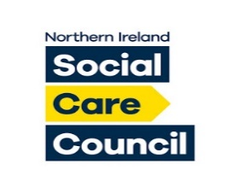

**Online Conference for Approved Social Workers in NI and their Managers**

***Programme and Registration details***

***Tuesday 26th October 2021***



***Registration details***

***Please register at:***

[***https://hscni-net.zoom.us/meeting/register/tZIlduurrjgpH9ZXypZ6q7Tp99ikgJ4IjR1o***](https://hscni-net.zoom.us/meeting/register/tZIlduurrjgpH9ZXypZ6q7Tp99ikgJ4IjR1o)

***After registering, you will receive a confirmation email containing information about joining the meeting***

***Programme***

*10.00-10.15* **Introduction to the morning** - *Sean Holland, Chief Social Work Officer, DoH*

10.15-10.45 **Approved Social Work Quality Standards and ASW workforce planning** - *Aine Morrison, Deputy Chief Social Work Officer & Gavin Davidson, Professor of Social Care, QUB*

10.45-11.00 **Break**

11.00-11.30 **Development and contribution of the ASW role** - *Phil Hughes, Former Director, NHSCT*

11.30-12.00 **High-Risk Professional Decision-Making in Mental Health** - *Cheryl Regehr, Vice-President, Provost & Professor of Social Work, University of Toronto*

12.00-1.00 **Focus on training and skills development**

1.00-1.30 **Lunch**

1.30-1.45 **Introduction to the afternoon** – *Siobhan O’Neill, Mental Health Champion for NI and Professor of Mental Health Sciences, UU*

1.45-2.15 **The impact of ASW practice on service users and carers** – *Martin Daly, Service User Consultant, BHSCT*

2.15-2.45 **Developments in the Approved Mental Health Professional role and context in England** – *Mark Trewin, Head of Alliance Building, Rethink Mental Illness and former Mental Health Social Work Lead, Department of Health and Social Care (England)*

2.45-3.00 **Break**

3.00-3.30 **Emotion management and complexities of the role** – *Sarah Vicary, Senior Lecturer & Associate Head of School, Open University*

3.30-3.50 **Focus on supporting ASWs**

3.50-4.00 **Conclusion** - *Aine Morrison, Deputy Chief Social Work Officer, DoH*

  