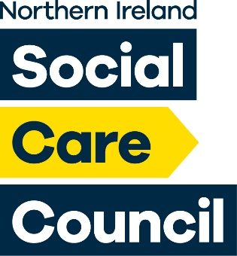
Funding Opportunity for Level 4 Certificate in Principles of Leadership and Management in Adult Social Care Northern Ireland:

Thank you for your interest in the funding opportunity that we have available for social care workers to achieve the Level 4 Certificate in Principles of Leadership and Management in Adult Social Care (NI). This opportunity will help to develop capacity and capability within the workforce
The Social Care Council has been working with the Health and Social Care Curriculum Hub (H&SC Hub) located at North West Regional Further Education College to facilitate opportunities for health and social care employers to link with Further Education colleges. This enhances the quality of the courses and qualifications that are offered at all Colleges in Northern Ireland, ensures they meet industry standards, are relevant, current, and, most importantly, support the needs of the end users in Health and Social Care
Through the work with the Hub we are delighted to be able to confirm that the Hub in partnership with Further Education will offer the Level 4 Certificate virtually. This means, therefore, that it does not matter what part of Northern Ireland you work/live in - you/your staff will be able to access this programme.
With this arrangement, through the H&SC Hub, there will be a community of learning from different services/locations which we hope will add to the learning experience for those undertaking this programme.
For more information on registration, costs and delivery of the programme please contact Caroline McKeever H&SC Hub Manager Caroline.McKeever@nwrc.ac.uk or Clare.Gallagher@nwrc.ac.uk

Information on Other Training Providers
There are other training providers offering this qualification; should that be the case please contact either of the Social Care Council contacts below:
meta.keenan@niscc.hscni.net
mervyn.bothwell@niscc.hscni.net

15 November 2021

