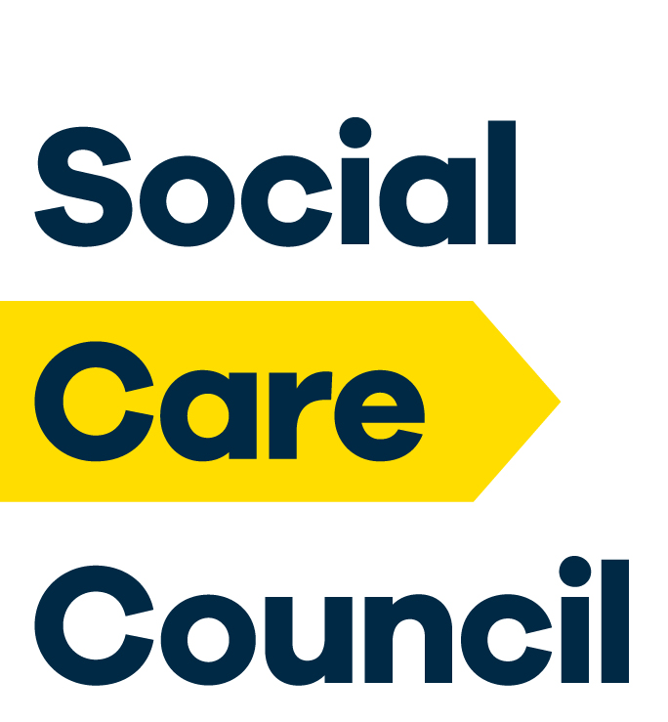

Approved Regulatory Bodies Policy
  - The Northern Ireland Social Care Council Fitness to Practise Rules 2019 define a ‘relevant regulatory body’ as ‘ a body in the United Kingdom or elsewhere that has responsibility for the regulation, audit, inspection, licensing or review of social care, health or education provision, or the regulation or licensing of a social care, health or teaching profession’.

  - The following bodies are to be regarded as ‘relevant regulatory bodies’ for the purposes of the interpretation and implementation of the relevant provisions within the Northern Ireland Social Care Council Fitness to Practise Rules.

- British Pharmaceutical Society
- Care and Social Services Inspectorate Wales
- Care Quality Commission (previously the Commission for Social Care Inspection)
- General Dental Council
- General Medical Council
- General Social Care Council
- General Teaching Council for England
- General Teaching Council for Northern Ireland
- General Teaching Council for Scotland
- General Teaching Council for Wales
- Health and Care Professions Council (previously the Health Professions Council)
- Nursing and Midwifery Council
- Pharmaceutical Society of Northern Ireland
- Regulation and Quality Improvement Authority
- Social Care Wales (previously Care Council for Wales)
- Social Work England
- Scottish Commission for the Regulation of Care
- Scottish Social Services Council
- Secretary of State for Education in England under Part 3, Section 8 of the Education Act 2011.

Reviewed August 2019

