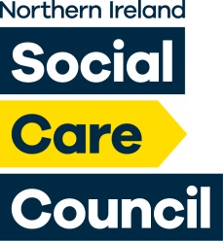

Northern Ireland Social Care Council

4th Floor James House

2 Cromac Avenue

Belfast | BT7 2JA

Tel: 02895362600

Web: [www.niscc.info](http://www.niscc.info)

**Audit and Risk Assurance Committee**

**Wednesday 19th June 2024 @ 1:30pm–**

**Via MS Teams**

**AGENDA**

|  |  |  |
| --- | --- | --- |
| 1. **Apologies** |  | **Chair** |
| 1. **Conflict of Interest** |  |  |
| 1. **External Audit**    1. Draft Report to those Charged with   Governance | ***Paper A*** | **NIAO** |
| 1. **Any Other Business** |  |  |
| 1. **Date of Next Meeting** | **Wednesday 2nd October @ 10:30 am** | |