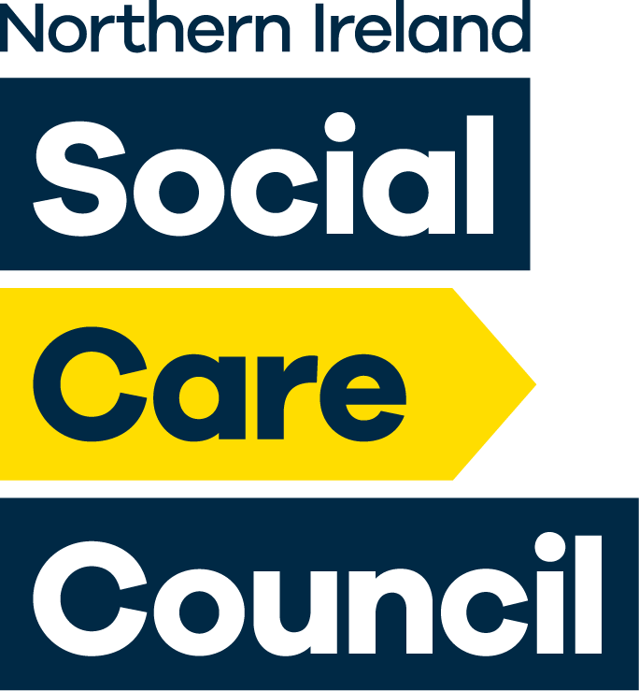

Chair of the Northern Ireland Degree in Social Work Partnership

Information Pack

Closing Date: 4.00pm Wednesday 5th April 2023
Interview Date: Tuesday 25th April 2023
(please note that this date is
provisional and is subject to change)

Contents

Introduction from Mr Paul Martin , Chair of Northern ireland Social Care Council 1
Role, Key Responsibilities and Representation 3
Role 3
Key Responsibilities 3
Representation 4
General Responsibilities 4
Personnel Specification 5
Essential Criteria 5
General 5
Qualification 5
Experience 5
Competencies 5
Personal Qualities 6
Desirable Criteria 6
Disqualification 6
On Appointment 8
Remuneration 8
Time Commitment 8
Location 8
Accountability 8
Responsible for 8
Term of Appointment 8
Conduct 8
Application Process 9
How to apply 9
Disclosure 9
Selection Process 9
Reasonable Adjustments 10
Equal Opportunities 10
Feedback 10
Complaints 10
Enquiries 10
Appendix 1 11
The Seven Principles of Public Life 11
Selflessness 11
Integrity 11
Objectivity 11
Accountability 11
Openness 11
Honesty 11
Leadership 11

Introduction from Mr Paul Martin, Chair of the Northern Ireland Social Care Council
The Northern Ireland Social Care Council (Social Care Council) is the regulator for the social care workforce in Northern Ireland (NI). Our purpose is to protect the public and safeguard people who use services through the regulation and development of the social work and social care workforce. We do this by registering social workers, social care workers and social work students, regulating standards in their conduct and practice and promoting their continuing professional development.
The Social Care Council sets standards and regulates education and training for the social work profession in NI at both qualifying and post qualifying level. This includes providing a specification for the Honours Degree in Social Work) and approving courses .
The Degree is the recognised professional qualification for social workers, probation officers and education welfare officers in NI. The Northern Ireland Degree in Social Work Partnership is an association of education institutions and statutory and voluntary employing agencies. Its main purpose is to ensure regional consistency in the development and delivery of agreed aspects of the Degree in line with Social Care Council standards.
The Partnership’s role is to facilitate regional approaches, protocols and procedures in areas such as student selection, practice learning, course content and other matters identified and agreed by the Degree Partnership, course providers and Social Care Council. This promotes regional consistency and makes best use of resources.
The Partnership promotes continuous improvement of course delivery to ensure that it remains fit for purpose, working with Social Care Council, academic institutions and employers across all sectors to put in place mechanisms so that key developments in social work practice inform curriculum delivery. It also seeks to ensure that formal and systematic input and feedback from service users, carers and students informs the delivery and development of key aspects of the Degree.
The Chair is responsible for leading the Degree Partnership, and for ensuring that it successfully discharges its responsibilities as set out in the Rules for the Approval of the Degree in Social Work (the Rules).
. The role of Partnership Chair demands an ability to inspire a shared purpose and encourage a group of individuals from a number of organisations and institutions to collaborate to produce agreed solutions. The Chair will also need an understanding of good governance systems and demonstrate a commitment to promoting member involvement in governance. We are looking for a qualified social worker with leadership and motivation skills to take on this role of Partnership Chair.
If you have the enthusiasm, vision, and commitment to lead a partnership of social work employers, education institutions, and other key stakeholders including service users and carers, to contribute effectively towards excellence in social work training standards for the Degree in Social Work in NI, we look forward to hearing from you.

Yours sincerely,
Paul Martin
Chair
Northern Ireland Social Care Council
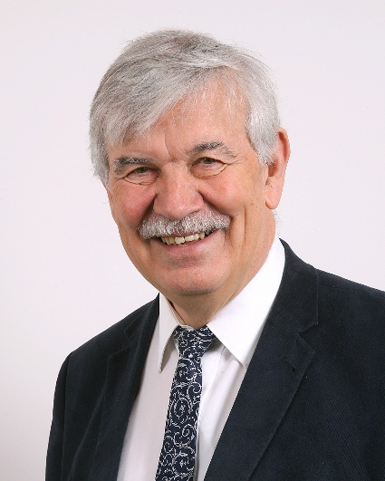

Role, Key Responsibilities and Representation

Role
It is the role of the Chair to:
- provide leadership and strategic direction to the Degree Partnership and play a full part in representing the activities of the Degree Partnership;
- enable all members of the Degree Partnership to make a full contribution to its business and activities;
- ensure that the Degree Partnership has adequate secretariat support, and is provided efficiently with all the necessary data to make informed and timely decisions and reports on matters pertaining to Degree Partnership business or on any aspect of course provision as required by the Social Care Council;
- ensure that the Degree Partnership maintains robust governance and financial management arrangements;
- ensure mechanisms are in place which allow formal and systematic input and feedback from the public, in particular service users, carers and students;
- agree with the Social Care Council any regional policies or approaches in relation to aspects of the provision of the Degree, such as the promotion of consistent standards, a regional admission system and practice learning arrangements;
- ensure that the Degree Partnership’s policies and activities are based on the principles of equal opportunity;
- ensure that the Business Services Organisation provides the necessary employment services to staff and has in place financial systems for the proper accounting and audit of the Degree Partnership finances.

Key Responsibilities
The Chair of the Degree Partnership is responsible for:
- contributing to the representation of membership across stakeholders of the Partnership in accordance with the Rules for the Degree in Social Work;
- in collaboration with stakeholders, developing organisational business plan and reporting on progress towards achievement of organisational objectives;
- consolidation of the governance arrangements which have been put in place and ensuring that membership of sub committees is representative of stakeholder interests;
- monitoring and ensuring the professional development of the Professional Officer in line with HRPTS policy and procedures;
- monitoring the performance of the Degree Partnership as a whole;
- ensuring that systems are in place for the communication and feedback of information between the Degree Partnership and course providers;
- overseeing reviews of the continuing relevance and validity of course provision.

Representation
The Chair of the Degree Partnership is responsible for:
- reporting and accounting to Social Care Council, including attendance at the Council’s Strategic Advisory Group and annual accountability meeting;
- establishing and maintaining effective links with social work employers, education institutions, and other key stakeholders including service users and carers;
- advising the Social Care Council and the Department of Health (DoH) and representing the Degree Partnership in its dealings with the Council, DoHor other Departments of Government;
- representing the Degree Partnership at official or social occasions relevant to Degree Partnership business.

General Responsibilities
- Assisting the Social Care Council in the fulfilment of its statutory duty under Section 75 of the Northern Ireland Act 1998 to provide equality of opportunity and the promotion of good relations;
- Supporting the Social Care Council in complying with its obligations under human rights legislation;
- Supporting the Social Care Council in meeting its obligations under risk management by adhering to the Controls Assurance Standards identified in the Council’s Risk Register;
- All duties must be carried out in compliance with the Social Care Council’s Health and Safety Policy and statutory regulations.

Personnel Specification
Applicants must clearly demonstrate in the form evidence of experience, competencies and personal qualities as set out in the undernoted criteria. Only information contained in the application form will be considered at the short listing stage. It is therefore important that completed application forms should reflect how, and to what extent, the criteria are met.

Essential Criteria

General
- The Chair of the Degree Partnership will be committed to the values of social work as set out in the Northern Ireland Social Care Council (Social Care Council) Standards of Conduct and Practice.

Qualification
- The Chair of the Degree Partnership must hold a social work qualification and be registered, or eligible to be registered, on the social work part of the Social Care Council Register.

Experience
- The Chair of the Degree Partnership must have an established track record of service and experience of leadership and management in a public service, voluntary, charitable, educational or commercial social work or social care organisation. That experience should include involvement in strategic planning and decision making.

Essential Criteria
The Chair must demonstrate competence in the nine dimensions of the healthcare Leadership Model, to include the following:

- Leadership
Experience of leading and developing through a period of change. Examples of the types of evidence the selection panel will be looking for are outlines below.
- An ability to inspire a shared purpose and encourage a group of individuals from a number of organisations and institutions to work together and to collaborate to produce agreed solutions
- A leadership style that creates a safe environment and enables issues to be discussed frankly and coherently
- Ability to work collectively and with compassionate in challenging or complex circumstances.

- Communication and Collaboration

Experience of collaborative working at a senior level demonstrating the ability to communicate complex information to a range of stakeholders. Examples of the types of evidence the selection panel will be looking for are outlines below.

- An ability to communicate in a way that creates a safe environment, enabling frank discussion to achieve consensus on complex interagency or organisational issues.
- An ability to manage conflict in a way that supports positive and productive relationships that develop partnership capability.
- A capacity / ability to achieve consensus on complex inter agency / organisational issues.

- Thinking Strategically
Experience of making a significant contribution to the strategic direction of an organisation. Examples of the types of evidence the selection panel will be looking for are outlines below.
- Anticipating future trends accurately
- A broad perspective as well as the ability to think strategically across systems
- Prioritising actions that will deliver the widest reach

- Good Governance
Experience of managing accountability and governance systems to support business planning, resource allocation, and reporting. Examples of the types of evidence the selection panel will be looking for are outlines below.
- Agreeing clear performance goals and quality indicators
- Supporting individuals and teams to take responsibility for results
- Providing balanced feedback
- Identifying and managing organisational risks

- Analyse information and make informed decisions
Experience of making decisions and solving problems in a team, organisational and interagency environment. Examples of the types of evidence the selection panel will be looking for are outlines below.
- Use appropriate methods of analysis to inform decisions
- Make decisions in a timely manner
Make collective decisions on the basis of analysis, wisdom, experience and judgement.
9. Applicants must also possess a full current driving licence and have access to a car or *form of transport which will permit the applicant to carry out the duties of the post in full.
(*This relates to any person who has declared that they have a disability which debars them from driving).

Desirable Criteria
Any of the following would be regarded as desirable:
- Experience in the field of education, training or development;
- Experience of social work or social care issues in a voluntary capacity or as a service user or carer, or as an advocate for users or carers of social care services.

Disqualification
The following criteria will disqualify an applicant from appointment to the Chair of the Degree Partnership:
- A person who is adjudged bankrupt or has made a composition or arrangement with his creditors;
- A person who has been dismissed, otherwise than by means of redundancy, from any paid employment with a public body;
- A person whose employment as a chairman or as a member or director of any body which employs social care workers has been terminated on the ground that -
(a) he / she failed without consent to attend three consecutive meetings of the board;
(b) it was not in the interests of, or conducive to the good management of, that body that he / she should continue to hold office;
(c) he / she failed to declare a pecuniary interest or withdraw from consideration of any matter in which he / she had a pecuniary interest.
- The person is employed by the Social Care Council or is a member of the Council or of its Fitness to Practise Committees;
- Any person whose application for registration as a social worker, social care worker or health care professional has been refused, withdrawn or suspended;
- Any person successfully investigated by social services and / or police (in the UK or any other country) due to concerns about their care or treatment of a child or vulnerable adult in either a work or home setting;
- Any person included on a list maintained by the Disclosure and Barring Service;
- Any person holding another position that could give rise to an actual or perceived conflict of interest with their appointment as Chair of the Degree Partnership.

On Appointment

Remuneration
The Chair of the Degree Partnership will receive £6,367 per annum (under review). He / she will also be eligible to claim travel and subsistence allowances, at rates set by the Council, for costs incurred on the business of the Degree Partnership.

Time Commitment
The Chair of the Degree Partnership will normally be required to devote a minimum of 3 days per month (under review) to the post. This may involve commitment outside normal working hours.

Location
The Chair will be based at Graham House, Knockbracken Healthcare Park, Belfast. He / she will also be required to travel throughout Northern Ireland to attend meetings, conferences etc., as necessary.

Accountability
The Chair of the Degree Partnership will be accountable to the Chair of the Northern Ireland Social Care Council through the Chief Executive of the Council.

Responsible for
The Chair of the Degree Partnership will be responsible for members of staff appointed to the Partnership..

Term of Appointment
The Chair of the Degree Partnership is normally appointed for a term of five years. The Chief Executive of the Council will conduct an annual review of the Chair’s performance throughout the period of the appointment.

Conduct
The Chair must set the highest standards of good governance for the Degree Partnership, keeping accountability, probity and openness at the heart of the management agenda.

You should note that being recruited to act as Chair of the Degree Partnership is an appointment rather than a job, and is not subject to the provisions of employment law.

Application Process

How to apply
You should complete and submit an application form, which can be downloaded from our website www.niscc.info.
Applications must be received by 4 pm on Wednesday 5th April 2023. Late applications cannot be accepted. We would encourage you to submit your application electronically to BusinessSupport@niscc.hscni.net.The time at which an electronic application is received will be determined by the time indicated automatically on the email. If you are sending an application by post, you should be aware that mail may not be delivered to Social Care Council until after 4 pm.
If you submit your application form electronically, you will receive an acknowledgement email within two working days. Hard copy applications will be acknowledged within five working days of receipt.

Disclosure
You should note that failure to disclose information on your application form surrounding disciplinary matters or criminal investigations or proceedings will be treated seriously and is likely to result in your term of appointment being terminated, and could result in fitness to practise proceedings being brought against you. Declaring information will not necessarily debar you from appointment.

Selection Process
An indicative timetable for the process is as follows:
Closing Date | Wednesday 5th April 2023 at 4 pm
Shortlist | Friday 7th April 2023
Interviews | Provisional date – Tuesday 25th April 2023

Shortlisting - applications will be shortlisted for interview against the personnel specification. You will be informed in writing whether or not you have been shortlisted for interview.
Interviews - interviews will be competency based and will last for approximately 30 – 45 minutes. An alternative date will be offered only at the discretion of the interview panel if you are unable to attend on the date set. All candidates who attend interview will be informed of the outcome within 14 working days.
Please note that the dates contained within the table above are indicative only. While all efforts will be taken to ensure that the timetable is adhered to, unforeseen circumstances may dictate a change in any or all of the above dates.

Reasonable Adjustments
Social Care Council welcomes applications from persons with a disability and persons without a disability. If you consider that a reasonable adjustment would be helpful at any stage of the process, please contact Sandra Stranaghan on 028 9536 2947 or at BusinessSupport@niscc.hscni.net .

Equal Opportunities
Social Care Council welcomes applications from all Section 75 groups regardless of age, disability, ethnicity, gender, marital status, people with dependents, political opinion, religion or sexual orientation.

Feedback
You may request feedback about any decision made concerning your application during the selection process. All requests for feedback must be made within seven days from the date of the written notification which you receive. Your request will be acknowledged within five working days.

Complaints
If you wish to make a complaint about any aspect of the selection process, you may do so by completing the Social Care Council Complaint Form. This can be accessed on the About Us section of our website, www.niscc.info. A complaint should be lodged within 28 days of the matter(s) complained of.

Enquiries
If you have an enquiry about any aspect of the role or about making an application, please contact Tricia Devlin, Professional Adviser, email tricia.devlin@niscc.hscni.net.

Appendix 1

The Seven Principles of Public Life
As a public body, the Social Care Council expects the following principles to be demonstrated:

Selflessness
Holders of public office should take decisions solely in terms of the public interest. They should not do so in order to gain financial or other material benefits for themselves, their family, or their friends.

Integrity
Holders of public office should not place themselves under any financial or other obligation to outside individuals or organisations that might influence them in the performance of their official duties.

Objectivity
In carrying out public business, including making public appointments, awarding contracts, or recommending individuals for rewards and benefits, holders of public office should make choices on merit.

Accountability
Holders of public office are accountable for their decisions and actions to the public and must submit themselves to whatever scrutiny is appropriate to their office.

Openness
Holders of public office should be as open as possible about all the decisions and actions that they take. They should give reasons for their decisions and restrict information only when the wider public interest clearly demands.

Honesty
Holders of public office have a duty to declare any private interests relating to their public duties and to take steps to resolve any conflicts arising in a way that protects the public interests.

Leadership
Holders of public office should promote and support these principles by leadership and example.

