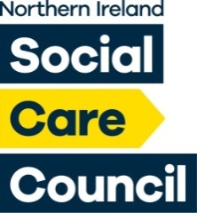

**Northern Ireland Social Care Council**

**PiP Team Meeting**

**06th February 2025**

**James House**

**AGENDA**

1. Welcome and Apologies
2. Young Scotland
3. Standing Items

* Risk Register
* PiP 2 Requirements
* IAR Assessment Point (Including CAR)
* PiP Partnership
* Programme Approval (Including WBLR)
* Annual Monitoring
* I & D
* Next Team Day

1. Leave
2. AOB
3. Date of Next Meeting: