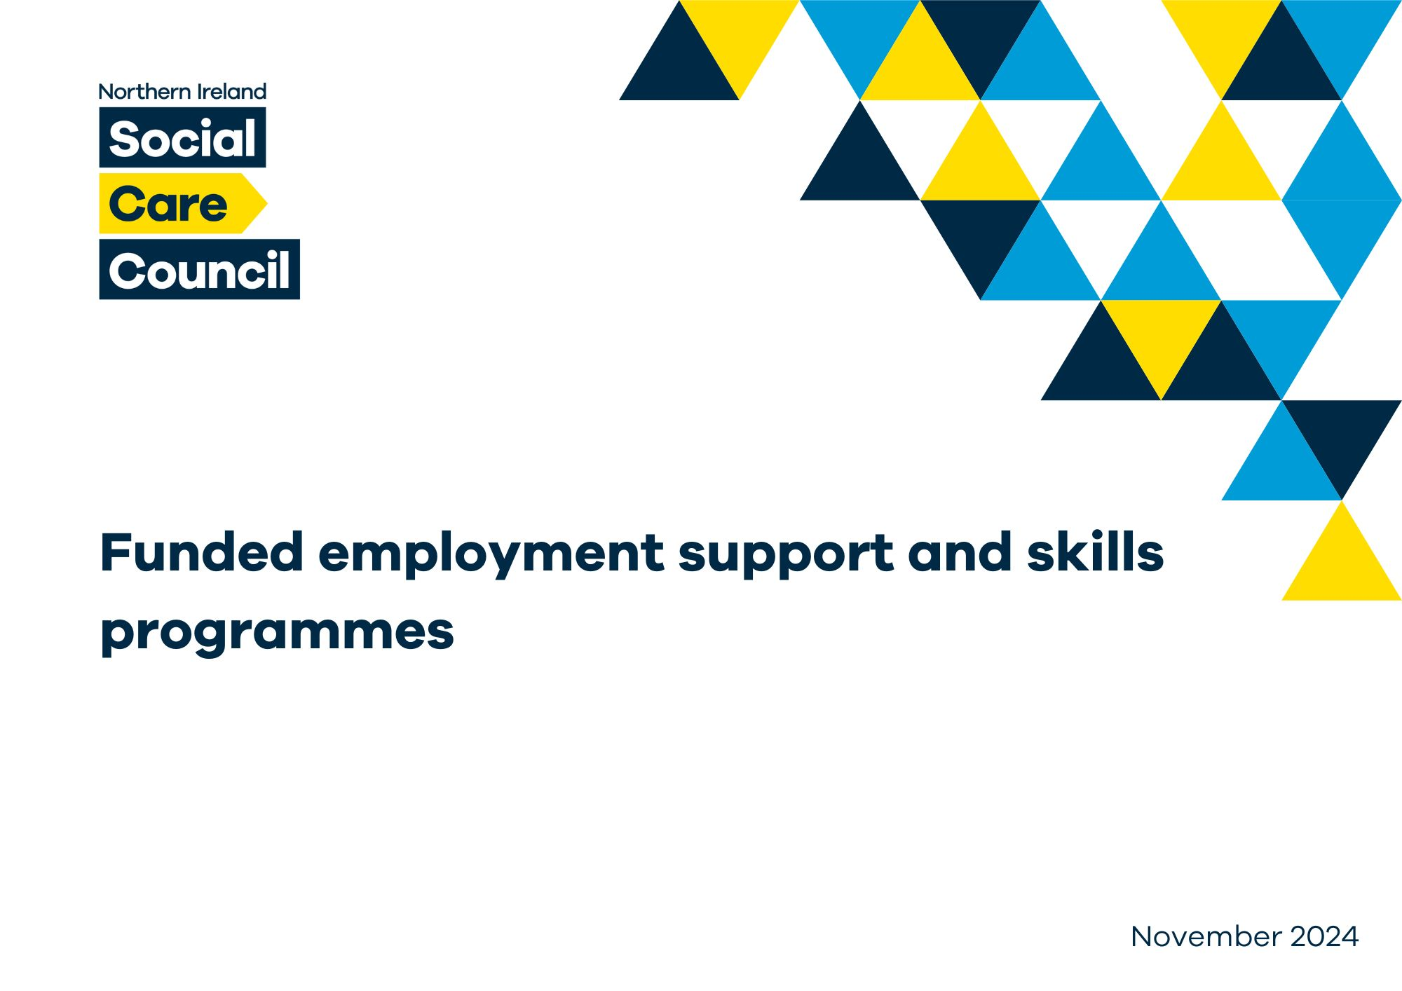

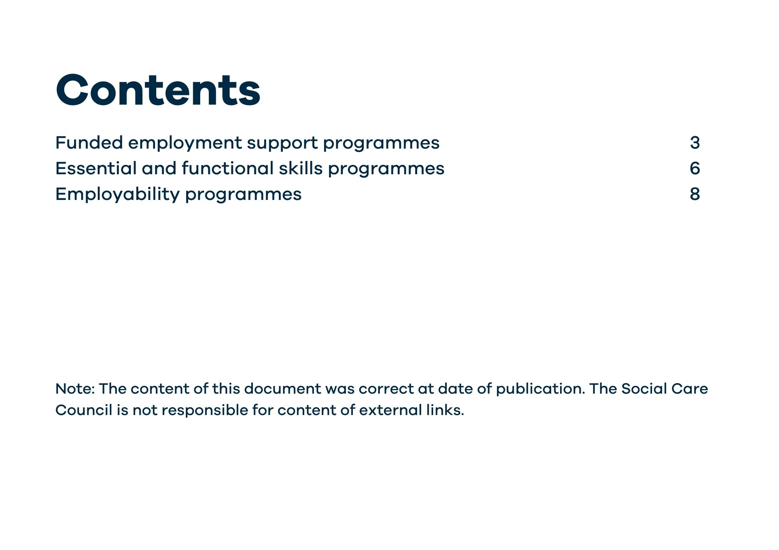

# Funded employment support programmes

|  |  |  |  |  |  |
| --- | --- | --- | --- | --- | --- |
| **Name of initiative** | **Overview** | **Funding stream** | **Eligibility criteria** | **Link/s** | **Provider/s** |
| Workable (NI) | Workable (NI) offers support to help people with disabilities who have barriers to employment to keep work. | Department for Communities (DfC) | * Have a disability. * Aged 16 or over. * About to start a new job or are having difficulties in your existing job. * Job is 10 hours or more on a minimum of a six- month contract. | [Workable (NI) |](https://www.nidirect.gov.uk/articles/workable-ni) [nidirect](https://www.nidirect.gov.uk/articles/workable-ni) | Workable (NI) is delivered by three providers contracted by the Department for Communities (DfC) as follows:   * [Workable NI - Support in the](https://www.disabilityaction.org/support-in-work) [workplace | Disability Action](https://www.disabilityaction.org/support-in-work) [Northern Ireland](https://www.disabilityaction.org/support-in-work) * [Supported Employment Solutions](https://www.sesni.org.uk/) [(sesni.org.uk)](https://www.sesni.org.uk/) * [Usel: Workable | Social](https://www.usel.co.uk/workable) [Enterprise | Helping People with](https://www.usel.co.uk/workable) [Disabilities or Health Conditions](https://www.usel.co.uk/workable) [Gain Employment](https://www.usel.co.uk/workable) |
| Access to Work - practical help at work | Access to Work supports people who want to enter employment or are having difficulties, related to their disability, in their current job. | Department for Communities (DfC) | * Have a disability. * Aged 16 or over. * Want to start a new job or are having difficulties in your existing job. | [Access to Work -](https://www.nidirect.gov.uk/articles/access-work-practical-help-work#toc-1) [practical help at](https://www.nidirect.gov.uk/articles/access-work-practical-help-work#toc-1) [work | nidirect](https://www.nidirect.gov.uk/articles/access-work-practical-help-work#toc-1) | Contact the Department for Communities (DfC) via:   * Email: [HealthandWorkSupportCo-](mailto:HealthandWorkSupportCo-ordination@communities-ni.gov.uk) [ordination@communities-](mailto:HealthandWorkSupportCo-ordination@communities-ni.gov.uk) [ni.gov.uk](mailto:HealthandWorkSupportCo-ordination@communities-ni.gov.uk) * Contact a work coach in your local [Jobs and Benefits office](https://www.nidirect.gov.uk/contacts/jobs-and-benefits-offices) |
| Step Up (16+ yrs. old)* | Step Up gives individuals an opportunity to develop confidence, build on existing skills, gain qualifications and explore career options while receiving one-to-one  mentorship. | Department for the Economy (DfE) and Department for Communities (DfC) | * People aged from 16 to 24 years old who are not in employment or education or training. | [Step Up – the](https://www.nidirect.gov.uk/articles/step-person-centred-skills-project) [person-centred](https://www.nidirect.gov.uk/articles/step-person-centred-skills-project) [skills project |](https://www.nidirect.gov.uk/articles/step-person-centred-skills-project) [nidirect](https://www.nidirect.gov.uk/articles/step-person-centred-skills-project) | Further Education Colleges and Higher Education Institutions of Northern Ireland. |

|  |  |  |  |  |  |
| --- | --- | --- | --- | --- | --- |
|  |  | ***Note****: Bursaries are available and will be aimed at all students with a background of care and students registered on Nursing, Allied Health and Social Work programmes who have confirmed caring responsibilities or disabilities.* | * People aged from 16 to 24 years old who care leavers. * People aged 24 years and over who are unemployed or economically inactive. * Young people and adults with a disability or Special Educational Needs. * Economically inactive women returners. |  |  |
| Skill Up (18+ yrs. old) | Skill Up is a flexible programme that offers individuals the opportunity to attend free accredited courses to enable the individual to re-train and re- skill. | Department for the Economy (DfE), as part of the Skills Fund. | * Aged 18 and over. * Eligible to work in Northern Ireland. | [SKILL UP – the](https://www.nidirect.gov.uk/skillup)  [flexible skills](https://www.nidirect.gov.uk/skillup) [programme |](https://www.nidirect.gov.uk/skillup) [nidirect](https://www.nidirect.gov.uk/skillup) | Further Education Colleges and Universities. |
| Condition Management Programme | The Condition Management Programme (CMP) helps individuals to manage health condition to support them to progress towards, move into and stay in employment.  ***NB*** *See link for details of health conditions* | Department for Communities (DfC) | * Struggling to stay in work due to a health condition * Have recently gone off work due to a health condition * Are receiving benefits and struggling to find work due to a health condition   *Taking part in the CMP is voluntary so it will not affect individuals benefits.* | [Condition Management Programme | nidirect](https://www.nidirect.gov.uk/articles/condition-management-programme#toc-1) | Contact an employment advisor or work coach in your local [Jobs and Benefits office](https://www.nidirect.gov.uk/contacts/jobs-and-benefits-offices)  **or**  Contact the CMP office in your local Health and Social Care Trust (HSCT). |

*Step Up has multiple pathway options depending on the individual’s life circumstances

# Essential and functional skills programmes

|  |  |  |  |  |  |
| --- | --- | --- | --- | --- | --- |
| **Name of initiative** | **Overview** | **Funding stream** | **Eligibility criteria** | **Link/s** | **Provider/s** |
| Essential Skills | Essential Skills courses help the individual to improve their ability to read, write, use mathematics and improve their computer skills. | Department for the Economy (DfE)  *All Essential Skills courses are free.* | * Aged 16 and over. * Resident in Northern Ireland. * Usually accessed by individuals who have left full-time education and have not achieved GCSE English and Mathematics at grade   A – C. | [Essential Skills |](https://www.nidirect.gov.uk/articles/essential-skills#toc-3) [nidirect](https://www.nidirect.gov.uk/articles/essential-skills#toc-3) | Accessed through Further Education (FE) colleges. |
| Multiply | The Multiply course aims to help individuals to improve their numeracy skills in daily life, home and work. | Department for the Economy (DfE), funded through the UK Shared Prosperity Fund | * Aged 19 plus+. * UK resident. * Individuals who do not already have a GCSE at grade C (or   equivalent) in maths.  **Note:** *Eligibility has recently been extended to 16-19-year olds who are at risk of becoming NEET (not in education, employment or training) in Northern Ireland.* | Search for Multiply courses on the following websites:   * [Local councils](https://www.nidirect.gov.uk/contacts/local-councils-in-northern-ireland) [in Northern](https://www.nidirect.gov.uk/contacts/local-councils-in-northern-ireland) [Ireland |](https://www.nidirect.gov.uk/contacts/local-councils-in-northern-ireland) [nidirect](https://www.nidirect.gov.uk/contacts/local-councils-in-northern-ireland) * [Universities](https://www.nidirect.gov.uk/articles/universities-and-colleges-northern-ireland) [and colleges in](https://www.nidirect.gov.uk/articles/universities-and-colleges-northern-ireland) [Northern](https://www.nidirect.gov.uk/articles/universities-and-colleges-northern-ireland) [Ireland |](https://www.nidirect.gov.uk/articles/universities-and-colleges-northern-ireland) [nidirect](https://www.nidirect.gov.uk/articles/universities-and-colleges-northern-ireland) | Accessed through Further Education Colleges (FE), universities and a number of voluntary and community organisations in collaboration with local councils as local labour market partnerships (LMP). |
| English for speakers of other languages (ESOL) | The ESOL course helps the individual to improve their everyday English speaking, listening, reading and writing. | Department for the Economy (DfE)  *ESOL courses are free for refugees, asylum seekers and other specific* | * There are no formal entry requirements for ESOL courses. * However, the individual will have to complete an initial | * [English for](https://www.nidirect.gov.uk/articles/english-speakers-other-languages-esol) [speakers of](https://www.nidirect.gov.uk/articles/english-speakers-other-languages-esol) [other](https://www.nidirect.gov.uk/articles/english-speakers-other-languages-esol) [languages](https://www.nidirect.gov.uk/articles/english-speakers-other-languages-esol) [(ESOL) |](https://www.nidirect.gov.uk/articles/english-speakers-other-languages-esol) [nidirect](https://www.nidirect.gov.uk/articles/english-speakers-other-languages-esol) | Accessed through Further Education (FE) colleges and a number of voluntary and community organisations. |

|  |  |  |  |  |  |
| --- | --- | --- | --- | --- | --- |
|  |  | *categories of displaced migrants.* | assessment when they apply for the course. | * [ESOL NI](https://esolwebapp.azurewebsites.net/) |  |

**Employability programmes**

|  |  |  |  |  |  |
| --- | --- | --- | --- | --- | --- |
| **Name of initiative** | **Overview** | **Funding stream** | **Eligibility criteria** | **Link/s** | **Provider/s** |
| Assured Skills (no specified age criteria) | The assured skills pre- employment training offers Academy-style training that will help someone to get a job by giving them the skills that companies want. | Department for the Economy (DfE) | * No specific criteria. Open to all individuals. | [Assured Skills](https://www.nidirect.gov.uk/articles/assured-skills-academies) [Academies |](https://www.nidirect.gov.uk/articles/assured-skills-academies) [nidirect](https://www.nidirect.gov.uk/articles/assured-skills-academies) | New foreign direct investment (FDI) companies and expanding local businesses in Northern Ireland. |
| Work Experience Programme (16 – 65  yrs. old) | The Work Experience Programme offers short work experience placements with local employers for people aged 16-65 years.  Placements can last between two and eight weeks and will give you the chance to try out various tasks in a real work situation and develop skills needed to help you get a job. | Department for Communities (DfC) | * Aged 18-65. * Receiving [Universal](https://www.nidirect.gov.uk/universal-credit) [Credit](https://www.nidirect.gov.uk/universal-credit) or [Jobseeker's](https://www.nidirect.gov.uk/articles/jobseekers-allowance) [Allowance,](https://www.nidirect.gov.uk/articles/jobseekers-allowance) Employment and Support Allowance or Income Support and actively.   seeking employment   * Be actively seeking not claiming benefits employment if you're unemployed and not claiming benefits. | [Work Experience](https://www.nidirect.gov.uk/work-experience-programme#toc-5) [Programme |](https://www.nidirect.gov.uk/work-experience-programme#toc-5) [nidirect](https://www.nidirect.gov.uk/work-experience-programme#toc-5) | Directly accessed by individuals seeking employment and employers through the DfC.   * Email: [WorkExperience@communities-](mailto:WorkExperience@communities-ni.gov.uk) [ni.gov.uk](mailto:WorkExperience@communities-ni.gov.uk). |
| Opportunity Guarantee - Work Experience Programme (16 – 24  yrs. old) | Opportunity Guarantee is a strand of the Work Experience Programme for young people aged 16-24. It builds on the Work Experience Programme with enhanced features:   * work experience placements of   thirteen weeks | Department for Communities (DfC) | * Aged 16-17 and receiving Universal Credit. | [Work Experience](https://www.nidirect.gov.uk/work-experience-programme#toc-5) [Programme |](https://www.nidirect.gov.uk/work-experience-programme#toc-5) [nidirect](https://www.nidirect.gov.uk/work-experience-programme#toc-5) | Directly accessed by individuals seeking employment and employers through the DfC.   * Email: [WorkExperience@communities-](mailto:WorkExperience@communities-ni.gov.uk) [ni.gov.uk](mailto:WorkExperience@communities-ni.gov.uk) |

|  |  |  |  |  |  |
| --- | --- | --- | --- | --- | --- |
|  | * a guaranteed interview for a job or apprenticeship when the placement ends. and * can link to a JobStart opportunity if the employer offers you a job after the   placement ends. |  |  |  |  |
| Job Works (18 – 24  yrs. old) | JobWorks is an employability programme aimed to meet the needs of young people aged 18-24 years who are not in education, employment or training. | Northern Ireland European Social Fund 2014-2020  Investment for Jobs and Growth Programme, Dept. for Employment and Learning. | * Young people aged 18 – 24. * Not in education, training or employment. * Living within the Greater Belfast area. | [Free employability](https://www.communityni.org/opportunity/free-employability-programme-18-24-year-olds) [programme for 18-](https://www.communityni.org/opportunity/free-employability-programme-18-24-year-olds) [24 year olds |](https://www.communityni.org/opportunity/free-employability-programme-18-24-year-olds) [CommunityNI](https://www.communityni.org/opportunity/free-employability-programme-18-24-year-olds) | Springboard Opportunities Limited |