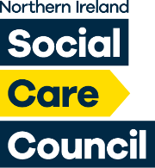

**NORTHERN IRELAND**

**SOCIAL CARE COUNCIL**

**QUALITY 2020 ANNUAL PROGRESS REPORT**

**APRIL 2023 – MARCH 2024**

**CONTENTS**

**Page**

|  |  |
| --- | --- |
| 3 | Chief Executive’s foreword |
| 5 | Our vision and values |
| 6 | Introduction |
| 8 | Progress against our 2023/24 action plan |
| 9 | Transforming the culture |
| 15 | Strengthening the workforce |
| 19 | Measuring the improvement |
| 22 | Raising the standards |
| 25 | Integrating the care |
| 28 | Action plan for 2024/25 |
| 29 | Organisational chart |
| 30 | Glossary of terms and abbreviations |

**FOREWORD BY PATRICIA HIGGINS, CHIEF EXECUTIVE**

**I am pleased to present the Northern Ireland Social Care Council’s (Social Care Council) Annual Quality 2020 Report for 2023/24. This is the 11th Report produced by the Social Care Council in response to the Quality 2020 Strategy which was produced by the Department of Health (DoH) in 2012.**

The Social Care Council is the regulatory body for the social care workforce in Northern Ireland and is responsible for promoting high quality standards of workforce training and practice.

Delivering quality services, quality initiatives and quality change remains important. The Social Care Council has adapted well to supporting the sector and being creative in the manner in which it engages - from online resources, lunchtime seminars and agile working. We strive to get the balance right between face to face and online engagement. We have a new Strategic Plan (for 2023-2027) and this will support how and what we deliver over these four years. Our new strategic plan is based on four strategic themes of: delivering effective regulation, developing the capability of the workforce, leading with influence, and innovating and improving.

During the year we refreshed our online registration system, including an upgrade to our Registration and Regulation ICT system, to make it more accessible to employers and new applicants, and updated our extensive range of Learning Zone resources, including an upgrade to our Registration and Regulation ICT system. We actively supported the Department of Health (DoH) in a number of campaigns including delivering communications campaigns for the Reform of Adult Social Care. We invested significant time in developing campaigns to raise awareness of the valuable contribution social workers and social care workers make to our community and our economy.

We were delighted to attain Investors in People Platinum accreditation which reflects the strength and compassion of our culture throughout the organisation – an organisation that is focused on quality improvement and quality outcomes.

We set outthe various ways in which we have delivered quality improvement in our business throughout this Report which are detailed under the following headings –

* Transforming the Culture;
* Strengthening the Workforce;
* Measuring the Improvement;
* Raising the Standards;
* Integrating with Care.

As in previous years’ Annual Quality Reports, we have also added an action plan for 2024/25 building on our learning to date and the environment in which we currently operate.

****We welcome feedback on this Report and our services generally, to help us ensure we are doing the right things in the right way to provide high quality services to all our customers and stakeholders.

**PATRICIA HIGGINS**

**CHIEF EXECUTIVE,**

**NORTHERN IRELAND SOCIAL CARE COUNCIL**

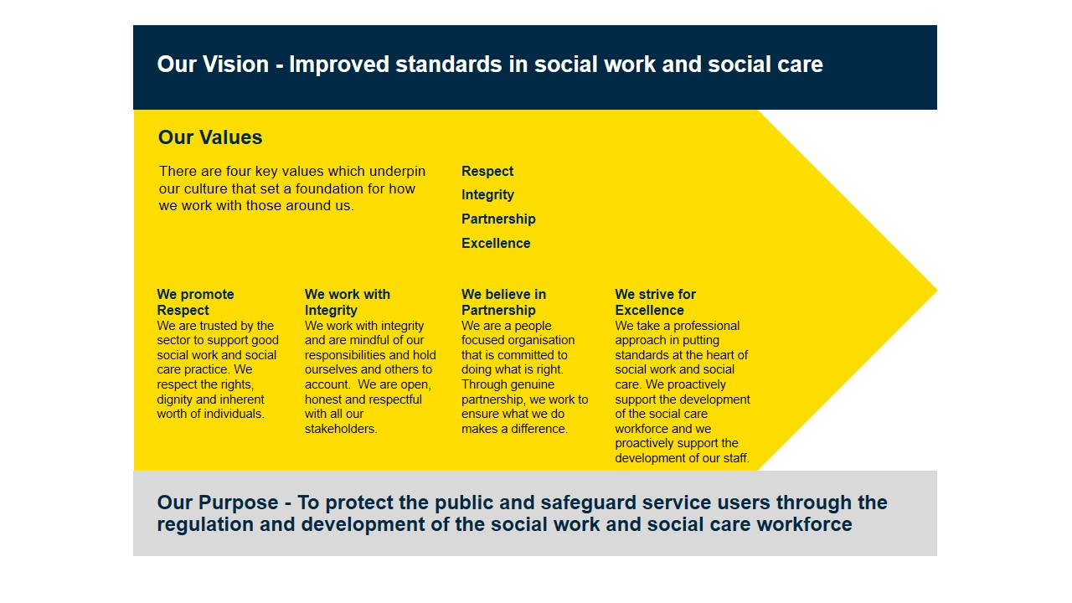

**INTRODUCTION**

When Quality 2020 was published by the then Minister of Health, Social Services and Public Safety in 2011, it set out a ten-year strategy with the guiding principle to protect and improve the quality of services delivered in health and social care. Significant progress has been made since then which is evidenced through each of our annual progress reports. We continued to make progress with our Quality 2020 programme during 2023/24 and this is explained in this year’s Q2020 Annual Report.

The ten-year strategy identified five strategic themes against which organisations, including the Social Care Council, could monitor progress and set achievable targets. These are –

* Transforming the Culture;
* Strengthening the Workforce;
* Measuring the Improvement;
* Raising the Standards;
* Integrating with Care.

The extent to which the Social Care Council has delivered against each of these themes is detailed throughout this Annual Report.

The Social Care Council is a non-Departmental Public Body sponsored by the Department of Health (DoH). It is the regulatory body for the social care workforce in Northern Ireland. Its role is to regulate and register social workers, social care workers and those studying for the Degree in Social Work. It also supports professional development across the workforce.

The Social Care Council’s vision is to ***‘Improve Standards in Social Care’***

To achieve this the Social Care Council delivers its work programme aligned to four strategic themes –

* ***Deliver effective regulation;***
* ***Develop the capability of the workforce;***
* ***Lead with influence; and***
* ***Innovate and improve.***

The Social Care Council’s core values are embedded in its work practices and culture. The four core values are –

* ***Respect – we promote respect***

We are trusted by the sector to support good social work and social care practice. We respect the rights, dignity and inherent worth of individuals.

* ***Integrity – we work with integrity***

We work with integrity and are mindful of our responsibilities and hold ourselves and others to account. We are open, honest and respectful with all our stakeholders.

* ***Partnership – we believe in partnership***

We are a people focused organisation that is committed to doing what is right. Through genuine partnership, we work to ensure what we do makes a difference.

* ***Excellence – we strive for excellence***

We take a professional approach in putting standards at the heart of social work and social care. We proactively support the development of the social care workforce and we proactively support the development of our staff.

**Registered Workforce**

The Social Care Council is responsible for the registration and regulation of the social care workforce in Northern Ireland. There were 46,418 people registered with the Social Care Council at the end of March 2024.

**PROGRESS AGAINST OUR 2023/24 ACTION PLAN**

Every year we set out a range of actions in support of our Quality 2020 agenda. Last year we set out three key actions of which two were completed. Of these three actions two were completed. The remaining outstanding action will be carried into 2024/25. A new action Plan for 2024/25 can be found on page 28 of this Report.

|  |  |  |  |
| --- | --- | --- | --- |
|  | ***ACTIVITY*** | ***HOW AND WHEN*** | ***PROGRESS*** |
| 1 | We will start a review on how quality is embedded in the organisation (with a view to reporting on this in the following business year). | **By March 2024** – we will create a hub of all evidence of quality improvement and initiatives and test for any gaps or missed opportunities. | **Ongoing**  We will take this forward as part of an overall review of the Intranet – and ensure that staff have access to information about quality, standards and Quality Improvement models to assist them in not only delivering high quality work but seeking ways to continually improve. |
| 2 | We will carry out a Quality Improvement initiative in a key area of business | **By March 2024** – we will have improved quality in our business with a model that can be used for future QI projects. | **Completed**  A quality improvement project was undertaken to explore options to reduce the number of referrals incorrectly reported to the Fitness to Practise Team. This is detailed further in this report. |
| 3 | We will improve our complaints management within the organisation so that we can gather better and more informed data from complaints and other forms of feedback. | **By March 2024** – we will have good data to help us improve our services and processes. | **Completed**  A review of the management of complaints was undertaken and a new policy and system put in place. This is detailed further in this report. |

**TRANSFORMING THE CULTURE**

**Q2020 states: “We will make achieving high quality the top priority at all levels in health and social care. We will promote and encourage partnerships between staff, patients, clients and carers to support decision making.”**

*This means creating a new and dynamic culture that is even more willing to embrace change, innovation and new thinking that can contribute to a safer and more effective service. It will require strong leadership, widespread involvement and partnership-working by everyone.*

**TRANSFORMING THE CULTURE IN THE SOCIAL CARE COUNCIL**

The Social Care Council delivers its services to the social care workforce (social workers, social care workers, and those studying for the Degree in Social Work) with the aim of ensuring people have a safe and high quality experience when using social work and social care services. In addition, the Social Care Council works with and supports a range of partners and stakeholders, including employers in the statutory, voluntary and private sectors, universities and colleges, commissioners, regulators and service users and carers.

In striving for excellence the Social Care Council ensures quality improvement is at the heart of its business. For this reason, the Social Care Council’s quality agenda sits across multiple levels of business operations which are explained below.

**Leadership**

The Social Care Council has two Directorates: Registration and Corporate Services, and Regulation and Standards. The Directors along with the Chief Executive comprise the Social Care Council’s Senior Leadership Team (SLT). ***An*** ***organisational structure for the Social Care Council is attached at Annex A.***

The Registration and Corporate Services Directorate is responsible for the registration of the social work and social care workforce, and a number of corporate service functions including Database Development, Finance, HR, Procurement, Administration, and Regulatory Committee Management.

The Regulation and Standards Directorate is responsible for the regulation of the social work and social care workforce including setting the Standards of Conduct and Practice for the workforce, setting the standards for and regulating social work education and training, and ensuring appropriate qualifications and training frameworks with relevant content and resources are in place to support the continuous development of both the social work and social care workforce. The Directorate is also responsible for investigating allegations relating to a registered worker’s fitness to practise. From 2023, the Directorate is also responsible for the social work and social care research and evidence agenda.

The Social Care Council accounts for its performance against quality standards in monthly Business Performance Reports to the SLT and to the Social Care Council’s Board in quarterly Business Performance Reports. Both reports focus on achievement of outcomes and identify areas for improvement, enabling SLT and/or the Board to scrutinise assurances, support innovation and make policy decisions. The Social Care Council also has an Evaluation Framework in place which details how it ensures the outcomes and impacts detailed in its Corporate and Business Plans are measured and analysed.

The Board, in providing strategic direction for the Social Care Council, has been actively committed to supporting quality improvement both within the Social Care Council and in its outward engagement, setting ambitious objectives that include an influencing role for the Social Care Council at a system leadership level across Health and Social Care. This positioning provides opportunity to influence and contribute to quality and improvement at a whole system level.

**Securing Involvement**

The Social Care Council has continued to ensure that it plans, delivers and assesses its business with a focus on high quality and improvement based on feedback, involvement and participation at all levels – including from registrants, service users and carers, staff and other stakeholders.

Examples of securing involvement in relation to staff during 2023/24 included –

* Senior Leadership Team (SLT) meetings with all staff to discuss a range of business matters. This includes monthly Townhall meetings with all staff across a range of topics including business plan development, learning from each other, sharing best practise and new initiatives.
* All staff were previously engaged in the development of the new Strategic Plan for 2023/24 to 2026/27 (during 2022/23). The new Strategic Plan was launched in April 2023 and staff continue to contribute to its delivery and the development of annual business plans to support the strategic objectives and outcomes.
* The Chief Executive and Senior Leadership Team held meetings with staff to congratulate individuals’ and teams’ efforts. This was supplemented with emails to all staff and teams noting key team achievements and milestones.
* Monthly team meetings take place across all teams in the Social Care Council where all team members can discuss projects which went well and those which have been a challenge. Monthly team meetings are in place across every team with information being cascaded between teams and also to the Operational Leadership Team (OLT) which comprises the heads of each function and with the SLT.

The Social Care Council has a ‘no blame’ culture and as part of this, continual learning and training around near miss and data breaches are discussed with relevant staff, procedures amended and improved if possible and learning taken forward from these issues. In addition, all managers encourage an open and honest dialogue with their teams to ensure staff feel they can raise issues. Securing involvement of staff is recognised as a critical element of creating a learning and improvement culture. This has highlighted the importance of listening and empowering people to lead and be part of real change.

**Investors in People**

In April 2023, the Social Care Council was awarded Investors in People (IIP) Platinum status which is the highest level on the IIP Framework. This is a significant achievement and reflects, among other things, the strong culture within the Social Care Council.

We have worked hard to develop a compassionate leadership culture and for this to be evidenced through the delivery of our core values and our behaviours. We continually reach out to our workforce to ‘take the temperature’ and ensure we are doing is being done well and is making a difference. We deploy our strapline – Working together, making a difference’ – not only to how we deliver our business but also how we support one another and across our teams.

As part of our IIP journey we also were awarded the Investors in People Health and Wellbeing at Gold Standard. Again, this is a tremendous achievement for a small arm’s length body who is committed to make a difference and supporting the wellbeing of its workforce in all that it does.

**Engagement**

The Social Care Council has a strong track record of engaging with its workforce but also in terms of engaging its registrants, stakeholders, service users and carers, and employers.

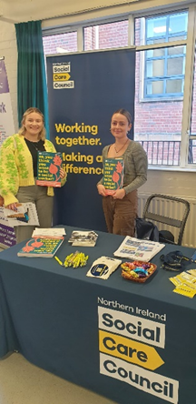During 2023-24, over 200 engagement opportunities were fulfilled, involving around 5,000 managers, social care workers, social workers, students and service users, at service settings, colleges, career seminars and public events across NI. The Social Care Council delivered presentations at workplace events to share information about the Social Care Council, registration, standards, learning and development with social care workers and managers. Sessions were also delivered to university students to introduce the Assessed Year of Employment (AYE) standards. The Professional in Practice (PiP) Framework information was shared in workplaces as part of induction and Continuous Professional Development (CPD) for social workers.

We also continued to deliver our lunchtime seminars online – with nine being delivered in 2023/24 (and over 1,000 online views). Topics covered included a presentation by the Department of Health ‘Social Work (NI) Supervision Policy 2024 – promoting quality supervision in social work’.

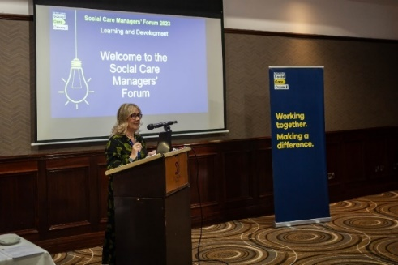We also delivered four Social Care Managers Forums during the year. These events aim to bring together managers from across the sector to update them on the new resources available to support them in meeting their responsibilities for registered staff. The event provided an opportunity for managers to share their views about the new Care in Practice Framework.

**Partnership Working**

The Social Care Council has a number of partnerships in place which supports its business. These are –

* Participation Partnership
* Registrants’ Forum (this forum was stood down during the year – and plans are in place to replace this with a Registrants Social Work Forum and a Registrants Social Care Forum)
* Leaders in Social Care Partnership
* Professional in Practice Partnership

Each of these Partnerships provides a structured means through which the Social Care Council can engage successfully with its stakeholders and review the quality of the service it provides. During 2023/24 each of these Partnerships have, where relevant, informed the work of the Social Care Council, provided feedback on draft policies and plans, informed the culture of the Social Care Council (particularly in relation to communications and the language used to engage with the social care workforce, service users and carers), and contributed to a more effective service through the challenge and assurance function they provide.

Participation Partnership

One of the ways in which the Social Care Council oversees its engagement with service users and carers is through its Participation Partnership which is chaired by a Board Member and co-chaired by two members (people who use services or carers), and comprises a number of people who use services and carers with a wide experience of the social care system in Northern Ireland. The Participation Partnership oversees the quality and quantity of engagement and challenges the way in which the Social Care Council designs and delivers its business, ensuring it is people focused and impactful.

The Participation Partnership, has been instrumental during the year in overseeing the quality and quantity of engagement by the Social Care Council, including –

* Participating on the Review of the Social Work Degree in NI.
* Engaging with social care workers and employers to learn more about their views on qualifications and a career structure for social care.
* Collaboration with the Social Care Council to progress the Communications and Engagement Plan from a service user/carer perspective
* Membership of the Social Care Collaborative Forum and workstreams for service user and carer involvement and the development of social care workforce data/intelligence.
* Development of resources to support recruitment, retention and wellbeing for the social care workforce, including the Values Based Retention Toolkit resource.
* Contributing to Degree in Social Work programmes through input with students’ taught sessions to provide insight into service user and carer experiences.
* Providing service users and carer perspectives to the NI Degree Partnership review of the Regional Protocol for Progression in Practice Learning.
* Ongoing support to develop Learning Zone resources, including the recently launched Human Rights Resource.
* Filming and editing of the short film ‘Where there’s a will, there’s a way’ featuring partnership member Joanne Sansome and Professor Joe Duffy, Queens University Belfast.
* 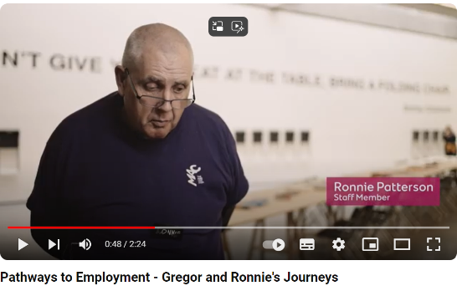Participation in videos and podcasts recognising innovative employment and support programmes for people who use services. (Group member Ronnie Patterson’s video from his role as Gallery Guide at The MAC Belfast.

Registrants’ Forum

The Social Care Council’s register at the end of March 2023 included over 46,000 registrants across Northern Ireland. The Social Care Council engages with its registrants using a range of methods and opportunities that include; direct email; provision of information and support on the website, learning and development resources on the Learning Zone, in Lunchtime Seminars and at through the Social Care Managers Forums, as well as in person events targeted for particular groupings. In June 2022 the Social Council’s Board initiated a review the Registrants Forum that had been in place for a number of years as it had limited impact or influence on the wide range of engagement activity that takes place on an on-going basis. The review is now complete and two new forums are being established – a Registrants Social Work Forum – and a Registrants Social Care Forum. While both of these forums will have their own work and engagement programme – they will also work collaboratively together.

Leaders in Social Care Partnership

The Leaders in Social Care Partnership consists of providers of social care services from the statutory, private and community and voluntary sectors, with a focus on supporting the transformation and development of the social care workforce in Northern Ireland. The Partnership is actively involved in work to support the DoH Reform of Adult Social Care, including work to develop career pathways for social care workers; promoting the role and value of social care; and building a data and intelligence framework for social care. The Partnership is closely connected into the DoH Social Care Collaborative Forum.

Professional in Practice Partnership

The Social Care Council supports a Professional in Practice Partnership which is chaired by a Board Member and comprises employers and Higher Education Institutions who are key to successfully supporting the delivery of the Professional in Practice framework for social workers. This enables the Social Care Council to ensure that the arrangements for supporting the professional practice of social workers remain fit for purpose and meaningful for those who extend their development using this route.

**STRENGTHENING THE WORKFORCE**

**Q2020 states: “We will provide the right education, training and support to deliver high quality service. We will develop leadership skills at all levels and empower staff to take decisions and make changes.”**

*The people who work in health and social care (including volunteers and carers) are its greatest asset. It is vital therefore that every effort is made to equip them with the skills and knowledge they will require, building on existing and emerging HR strategies, to deliver the highest quality.*

**STRENGTHENING THE WORKFORCE IN THE SOCIAL CARE COUNCIL**

The Social Care Council has a staffing complement of 62 staff at end March 2024. Details on the Social Care Council’s staffing complement can be found in the annual report and accounts on the website – [www.niscc.info](http://www.niscc.info)

Staff are engaged across the following areas -

* Administrative Staff – often providing front line services;
* Managers – including team leaders and heads of function;
* Professional Advisers – professionally qualified social workers;
* Directors – who form part of the Social Care Council’s SLT.

Social Care Council staff work using a variety of working patterns including full-time, part-time, job-share and compressed hours. They can also avail of flexi time, special leave (including carers leave), career breaks and unpaid leave. On appointment, staff can sign up to the organisation’ agile working policy. Staff are assigned across two Directorates as demonstrated below –

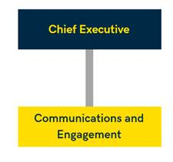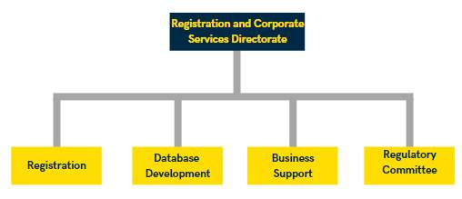

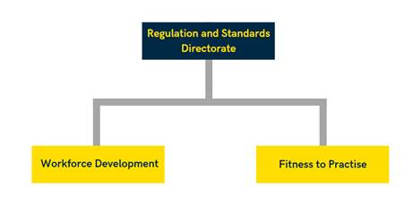

**Appraising, Learning and Developing**

The Social Care Council promotes a learning culture across all aspects of the organisation, including empowering individuals to take control of their own development and career management. In support of this all staff are required to have a set of SMART[1] objectives in place which reflect an individual’s/team’s contribution to the Social Care Council’s Corporate/Strategic Plan, Business Plan, Operational Plan and Key Performance Indicators and Standards.

All staff operate an appraisal called ‘Quarterly Check-Ins’ which take place four times a year. They provide a collaborative approach to review and enable the individual and their manager to focus on the conversation rather than the paperwork against a simple framework which is designed around the individual organisational footprint. The system was designed on the back of feedback from staff that the current system was paper heavy, and was sometimes a ‘tick box’ exercise with many staff seeing the appraisal as something that was done to them rather than with them. We also set up a system to ensure all newly appointed staff and newly appointed managers are trained in the system and understand their role, and what is expected of the staff member and their manager.

**In 2023/24, 100% of staff had an annual performance appraisal and a learning and development plan agreed by end June 2024.**

Learning and Development Plans for all staff in the Social Care Council are reviewed to identify team training needs, essential and developmental needs, and professional learning. This work is carried out by the Social Care Council’s Operational Leadership Team (OLT) which comprises each of the Head of Functions across all of the business areas in the Social Care Council (Fitness to Practise, Workforce Development, Corporate, Committee, Communications, Registration, and Database teams). OLT review the individual, team and organisational training needs and identify where these can be delivered in partnership with the HSC Leadership Centre, who the Social Care Council have a Service Level Agreement with.

**Compassionate Leadership**

All of the managers in the organisation (from Team Leader to Chief Executive) co-designed a Compassionate Leadership Programme – based on Michael West’s book ‘Compassionate Leadership – Sustaining Wisdom, Humanity and Presence in Health and Social Care’.

The managers shared the research, development and delivery of a themed chapter each – to be delivered over a 12-month period. New and more experienced managers collaborated to deliver learning for all across a range of compassionate leadership styled themes (including reflective practice, self-care, leading teams with compassion).

The programme finishes in 2024/25 and this will be further reported on next year.

**Recognising Good Performance**

The Social Care Council appreciates the importance of taking time to recognise and acknowledge good performance whether that is on an individual basis, as a team, or for the organisation as a whole. Feedback from IIP Reports indicate that managers in the Social Care Council are well equipped and skilled on giving direct feedback, in a positive and constructive way, while also acknowledging excellent work that stands out whether as a result of an individual/teams commitment, or as a result of the challenge the work presented in the first instance.

This type of feedback manifests itself on a day to day basis, through one to one meetings and through mid-year and end-year performance appraisal reviews. At the same time, the Senior Leadership Team and the Board take the time to email and/or meet staff to personally acknowledge the success of a team/teams and of the organisation.

Providing an interactive culture which provides time for staff to connect in this way is also underpinned by the SLT’s commitment to supporting the Social Care Council’s Health and Wellbeing Committee. The Health and Wellbeing Committee organised a number of functions throughout the year both online and in person (once it was safe to do so). Teams had an opportunity to interact, including with teams whom they might not normally have an opportunity to engage with on a day to day basis.

In addition to these ‘staff events’, the Health and Wellbeing Committee also takes an active role in organising and supporting a number of charities throughout the year, including some online challenges to keep teams connected, healthy and motivated.

**Values and Behaviours**

The Social Care Council’s Corporate Plan identified four corporate values for the organisation –

* ***Excellence*** – we are committed to excellence in everything we do;
* ***Respect*** – we respect the rights, dignity and inherent worth of individuals;
* ***Integrity*** – we are honest and work in an open and transparent way;
* ***Partnership*** – we are a listening and learning organisation. Working in partnership to ensure what we do makes a difference.

The Social Care Council continues to use as many opportunities as possible to embed and promote its values, including ensuring they are reflected in policies and strategies, and in recruitment and job descriptions.

**Senior Leadership Commitment to Quality**

Ensuring a quality agenda and culture exists, and can be evidenced throughout the Social Care Council, starts at the top level of the organisation and is led by the senior leadership structure.

The Social Care Council’s Senior Leadership Team ensure quality and evidence of quality (business reports, feedback reports, evaluation) is part of their regular agenda. At the same time, and to cascade this approach, the SLT put in place an Operational Leadership Team (OLT) which comprises the heads of function from each of the areas across the organisation (Fitness to Practise, Workforce Development, Corporate, Committee, Communications, Registration and Database). OLT meet monthly and report to SLT; not only on the day to day business (delivery, outcomes, risks), but also issues in relation to quality, service improvement, culture, and learning and development.

As part of this work, OLT required all staff to complete the e-learning module on Q2020 Attributes Framework level 1, which was achieved. The module also forms part of the induction programme for all new staff appointed to the Social Care Council.

**MEASURING THE IMPROVEMENT**

**Q2020 states: “We will improve outcome measurement and report on progress for safety effectiveness and the patient/client experience. We will promote the use of accredited improvement techniques and ensure that there is sufficient capacity and capability within the HSC to use them effectively.”**

*The delivery of continuous improvement lies at the heart of any system that aspires to excellence, particularly in the rapidly changing world of health and social care. In order to confirm that improvement is taking place we will need more reliable and accurate means to measure, value and report on quality improvement and outcomes.*

**MEASURING THE IMPROVEMENT IN THE SOCIAL CARE COUNCIL**

The Social Care Council understands the need to have robust and reliable information to hand to help inform whether it is doing things well – or well enough. To support this the Social Care Council has a number of reporting and feedback mechanisms in place which include –

* Annual business objectives which are reported to the Board/SLT on a quarterly basis;
* Monthly business reporting to SLT;
* Key Performance Indicators and Quality Standards;
* Internal Audit Reviews and compliance reports;
* Data Quality Reports;
* Surveys, reviews and evaluations;
* Customer Feedback Reports;
* Complaints Management and Learning Reports;
* Robust Registration database and reporting.

Staff at all levels are encouraged to challenge processes that are no longer effective. As an example, a number of registration procedures have been improved such as enabling registrants to advise the Social Care Council of changes of contact details and employment over the phone, rather than asking registrants to put their request in writing. This has improved the customer service experience for registrants who can get certain issues resolved quickly in a way that best suits them.

Teams also meet on a monthly basis to review their own performance and suggest ways in which work can be streamlined and improved to the direct benefit of those people we provide a service to.

All of these arrangements do not however operate in isolation; instead they are open to challenge, review and compliance assurance. This includes reviews by Internal Audit to provide relevant assurance, and oversight by the Social Care Council’s Audit and Risk Assurance Committee.

**Quality Improvement in Service Delivery**

During 2023/24, the Social Care Council delivered the following –

* Development of new Learning Zone resources;
* 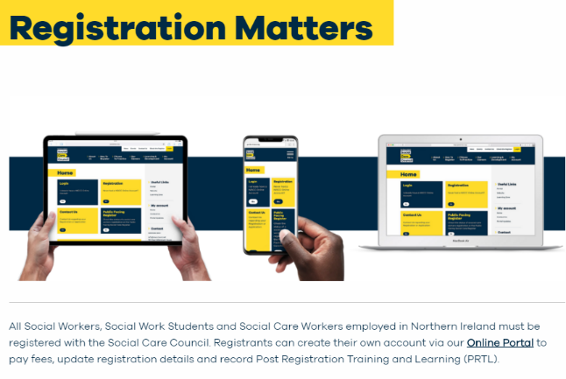The establishment of an internal Data Quality Assurance Group to review the quality of data and develop an action plan to address any gaps;
* A campaign to promote awareness of why registration matters.
* A campaign to promote social care – Social Care Matters.

The Social Care Council led or contributed to workstreams to support the DoH in developing social work and social care workforce intelligence; working together to improve the quality of workforce data. Improving and aligning data will facilitate intelligence gathering about the workforce to provide a unified view of the workforce across NI. The Social Care Council contributes to groups of subject experts to inform policy development and implementation to support population wellbeing.

Emerging technologies are key to transforming social work and social care service delivery to meet the changing needs of our communities. The Social Care Council is a member of the Digital Health and Care NI (DHCNI) project team to develop digital capability for health and social care in NI. DHCNI strategy focuses on enabling health and social care staff to have the right information in the right place at the right time to ensure effective, efficient and safe decision-making. The Social Care Council is providing insight into digital capabilities and attitudes towards the use of technology to inform the development of the Digital Capability Strategy and forthcoming Digital Capability Framework. Together with our digital partners, we are seeking to motivate and support a workforce that can confidently use digital health technologies to deliver health and social care.

The Social Care Council has continued to support the networks of leaders, managers and registrants across social work and social care to ensure the voice of the sector is represented in the forums that are shaping future policy and services. The Social Work Data & Intelligence Workstream continued work on developing systems and processes to share data and intelligence across the social work workforce. Workshops held in April and June to map data needs and opportunities. A pilot real-time dashboard for workforce data was developed to test how data could be mapped and merged successfully.

**Complaints Management**

It is important for any organisation to provide a clear mechanism for dispute resolution, particularly if an individual is concerned about the service they have received, how they were treated by a member of staff or the systems/processes which are in place in the Social Care Council’s business.

The Social Care Council encourages its staff that wherever possible, complaints or disputes are managed locally and at source where an immediate resolution can resolve concerns, and reduce the stress or anxiety caused to the individual. The Social Care Council also recognises that, at times, having a mechanism (through the organisation’s Complaints Policy) provides a means through which a complaint can be independently reviewed and investigated.

During 2023/24, the Social Care Council reviewed its policy and processes to help it capture complaints and feedback in all its forms. The new Policy was published in 2023 and the data being gathered is helping the organisation to develop learning across the functions. Heads of functions across the teams now take first line responsibility for investigating and responding to complaints and feedback – and a system is in place for this data to be shared centrally to inform reporting and lessons learnt.

**RAISING THE STANDARDS IN THE SOCIAL CARE COUNCIL**

**RAISING THE STANDARDS**

**Q2020 states: “We will establish a framework of a clear evidence-based standards and best practice guidance. We will establish dynamic partnerships between service users, commissioners and providers to develop, monitor and review.”**

*The service requires a coherent framework of robust and meaningful standards against which performance can be assessed. These already exist in some parts, but much more needs to be done, particularly involving service users, carers and families in the development, monitoring and reviewing of standards.*

The Social Care Council promotes its Standards of Conduct and Practice including a suite of Easy Read versions. During the year we supported the sector in embedding the Standards in particular as the workforce responded to the unprecedented demands and challenges of the pandemic.

The Standards of Conduct and Practice explain the standards expected of the social care workforce in Northern Ireland. They set out very clearly what is expected in terms of an individual worker’s conduct i.e. values, attitudes and behaviour as well as standards for their Practice which outline the knowledge and skills required for competent practice.

Only a very small percentage of registrants breach the Standards expected and where this happens the FtP team have a range of measures available proportionate to the event which occurred.

**Standards**

The Social Care Council takes a proactive approach towards reducing the number of registrants whose conduct or practice falls below the standards required for registration. Fitness to Practise and Workforce Development Teams worked together on a programme of workforce engagement and education to improve understanding about the workforce standards and to share learning about issues that cause registrants to be referred to Fitness to Practise.

Collaborative work was undertaken with RQIA and employers to strengthen the connection between workplace practices, inspection standards and the Standards for Conduct and Practice. Pressures within the sector and limited engagement with RQIA meant the pace of work has not progressed as far as originally visioned, but can only progress at a pace that enables all participants to fully engage. This work will continue into 2024-25.

The Social Care Council also completed an analysis of referrals received in the last 10 years to look for themes or indicators causing registrants to breach their Standards. This report was presented to social work and social care teams and managers at events across Northern Ireland. The report highlights the types of concerns more prevalent in certain services or settings and is assisting with a more targeted approach to the education activities supporting our preventative upstreaming agenda. The team also worked with South Eastern Health and Social Care Trust on a Learning from Complaints pilot. Tools developed as part of this pilot for sharing learning from complaints will be taken forward in 2024-25 to mainstream and regionalise them.

**Learning Zone**

The Social Care Council’s Learning Zone provides a wide range of free resources for registrants and their managers to use to guide them on meeting the standards expected of registrants and their employers. 1,000 people view the learning resources about the Standards of Conduct and Practice, guidance and interactive tools on the Learning Zone every month. During the year, Fitness to Practise and Workforce Development teams collaborated on the development of new learning resources to support registrants.

The new digital learning resource – Human Rights for Social Workers was launched on United Nations World Day of Social Justice. It is aimed at social workers and social work students to support them to understand human rights, the legal framework and how human rights are applied. The resource examines each human right that social workers may encounter in their work and the situations they may apply to. This resource is available from the [Learning Zone](https://learningzone.niscc.info/learning-resources/human-rights-for-social-workers/). Development work was also undertaken for a resource to support social workers in managing ‘All things Digital’. This will be launched in 2024-25.

**Professional in Practice Framework**

The Social Care Council’s Professional in Practice (PiP) Framework continues to make a positive impact on the professional development of social workers. Engagement with the framework enables social workers to gain professional recognition for their learning and development that improves the quality of their practice.

In June 2023, 184 social workers who had achieved PiP Awards were invited to receive their award at a ceremony with family and line managers. The event was an opportunity to recognise the commitment of social workers to their professional development. The Chief Social Work Officer and the Lord Mayor of Mid and East Antrim joined the event to offer their congratulations to the successful awards recipients.

PiP Social Work Awards presented included:

* 36 NI Consolidation Awards.
* 136 NI Specialist Awards.
* 11 NI Leadership and Strategic Awards.
* 1 NI Advanced Scholarship Award.

**Social Work and Social Care Research and Evidence**

During 2023/24, the Social Care Council was given responsibility for two important areas of work - implementing the Leadership in Social Work Framework and taking responsibility for the Social Work and Social Care Research Strategy.

Bringing the Social Work and Social Care Research Strategy into the work of the Social Care Council is an excellent opportunity to build on the existing work of the social work and social care research community, and to develop new partnerships to influence the development of research that informs best practice for social work and social care.

We will report on this further in our next report.

**Quality Improvement Initiative**

A quality improvement project was undertaken to explore options to reduce the number of referrals incorrectly reported to the Fitness to Practise Team. The project involved surveys and interviews with people who had recently made a referral. It also reviewed the guidance published to assist people deciding whether a concern meets the threshold for a Fitness to Practise investigation.

This work will be completed in 2024/25 with the revision of guidance material and information sharing with social care employers.

**INTEGRATING THE CARE**

**Q2020 states: “We will develop integrated pathways of care for individuals. We will make better use of multidisciplinary team working and shared opportunities for learning and development in the HSC and with external providers.”**

*Northern Ireland offers excellent opportunities to provide fully integrated services because of the organisational structure that combines health and social care and the relatively small population that it serves. However, integrated care should cross all sectoral and professional boundaries to benefit patients, clients and families.*

**INTEGRATING THE CARE IN THE SOCIAL CARE COUNCIL**

The Social Care Council is an organisation of the health and social care sector in Northern Ireland. While provided with a specific remit regarding the regulation and registration of the social care workforce, it carries out its functions in close working partnerships with others in the health and social care sector in Northern Ireland.

The Social Care Council is represented on all relevant groups and committees and is active in contributing to and driving forward the agenda to the benefit of the social care workforce. It also integrates its work at a direct level with employers, Trusts, universities, the voluntary and community sectors, and service users and carers.

**Systems Leadership Agenda**

During the year, the Social Care Council continued to work to support and inform the systems leadership agenda across the HSC and beyond.

The Board of the Social Care Council identified a key ambition for the organisation to inform leadership at all levels across Health and Social Care. The Social Care Council continues to work to both contribute and influence the development and transformation of the system as well as being a connector for many parts of the system that do not always have a prominent position.

The Social Care Council brings together key interests from across the social care sector to discuss strategic issues and identify opportunities for shared working to improve recruitment and retention, development, profile and positioning of the workforce.

During the year the Social Care Council had a focus on supporting and strengthening social care leadership networks. The Leaders in Social Care Partnership developed a detailed programme of work based on collaboration and outcomes. It brings together senior social care leaders from the statutory, independent and 3rd sectors to establish a strategic framework for the transformation and development of the social care workforce in Northern Ireland that will ensure the sustainability of a skilled, competent and fit for purpose workforce.

The Social Work Leadership Network was established under the auspices of the DoH Social Work Strategy and comprises leaders from the statutory, voluntary, education and justice sectors. The Network is focussed raising the profile of social work in all sectors, working towards a collaborative approach to developing the social work workforce into the future. The Social Care Council has also continued to support the 3rd Sector social work leadership group, ensuring the voice of the 3rd sector is included in strategic discussions about the future of social work.

In recognising the value of collective leadership across the Health and Social Care system, as well within the regulatory system, we worked with a range of networks of people who collaborate on development and improvement. Our work to connect social work and social care leaders is helping to shape social work and social care as health and social care transformation moves forward. Now, more than ever, insight from sector leaders is needed to inform strategic workforce planning and development.

Through our strategic Partnerships we continued to support the development of leadership capacity and positioning in social work and social care. The Social Care Council hosted a workshop with social work leaders to explore the implementation of the Social Work Leadership Framework. The framework was developed by the DoH and has been given to the Social Care Council to lead its implementation.

**Social Care Collaborative Forum** -– The Social Care Collaborative Forum (SCCF) has been established by the DoH to take forward work to support the Reform of Adult Social Care. The Social Care Council Chief Executive is the Co-Chair of the SCCF and during 2023-24, Social Care Council staff supported the work of the Forum through participation in workstreams. This included leading on the work to develop a career pathway for social care workers; leading the promotional campaigns for social care; and leading work to develop a common dataset for social care.

**Joint Working with Other Regulators** – The Head of Fitness to Practise is an active member of NI Joint Regulator’s Forum. This forum has developed a Shared Intelligence Framework/Emerging Concerns Protocol which provides a structure and mechanisms for regulators to share information that may indicate risks to people who use services, carers and families. Staff also provide support and share knowledge with other regulators in UK and Ireland to support consistency in social work and social care education, training and practice.

**Social Work Leadership** - The Social Care Council hosted a workshop with social work leaders to explore the implementation of the Social Work Leadership Framework. The framework was developed by the DoH and has been given to the Social Care Council to lead its implementation. We are working in collaboration with the five HSC Trusts, and the Centre for Effective Services to develop an implementation plan.

**UK and Ireland Social Work and Social Care Alliance** – The Social Care Council is a member of this Alliance working with the social work/social care Regulators in the UK and Ireland, along with Skills for Care in England. During 2023-24 the Alliance commissioned work to develop a report on the Economic Value of Social Care within the UK.

**SOCIAL CARE COUNCIL QUALITY 2020**

**ACTION PLAN 2024/25**

To inform the Social Care Council’s continued improvement in relation to embedding quality, demonstrating quality and measuring quality outcomes, it has identified the following areas for delivering during 2024/25 –

|  |  |  |
| --- | --- | --- |
|  | ***ACTIVITY*** | ***HOW AND WHEN*** |
| 1 | Include access to quality improvement data and resources in the overall review of the Intranet. | **By March 2025** – we will make available quality resources through our Intranet. |
| 2 | Improve data quality information through the development and roll-out of the case management system for Fitness to Practise and Committee. | **By January 2025** - a new case management system will be in place to support FtP and Committee data and information. |
| 3 | Commence a review the shared drive (x-drive) with a view to improving data and information asset management. | **By March 2025** – we will have commenced a review of the current system and got agreement on the way forward for shared information asset management and control. |

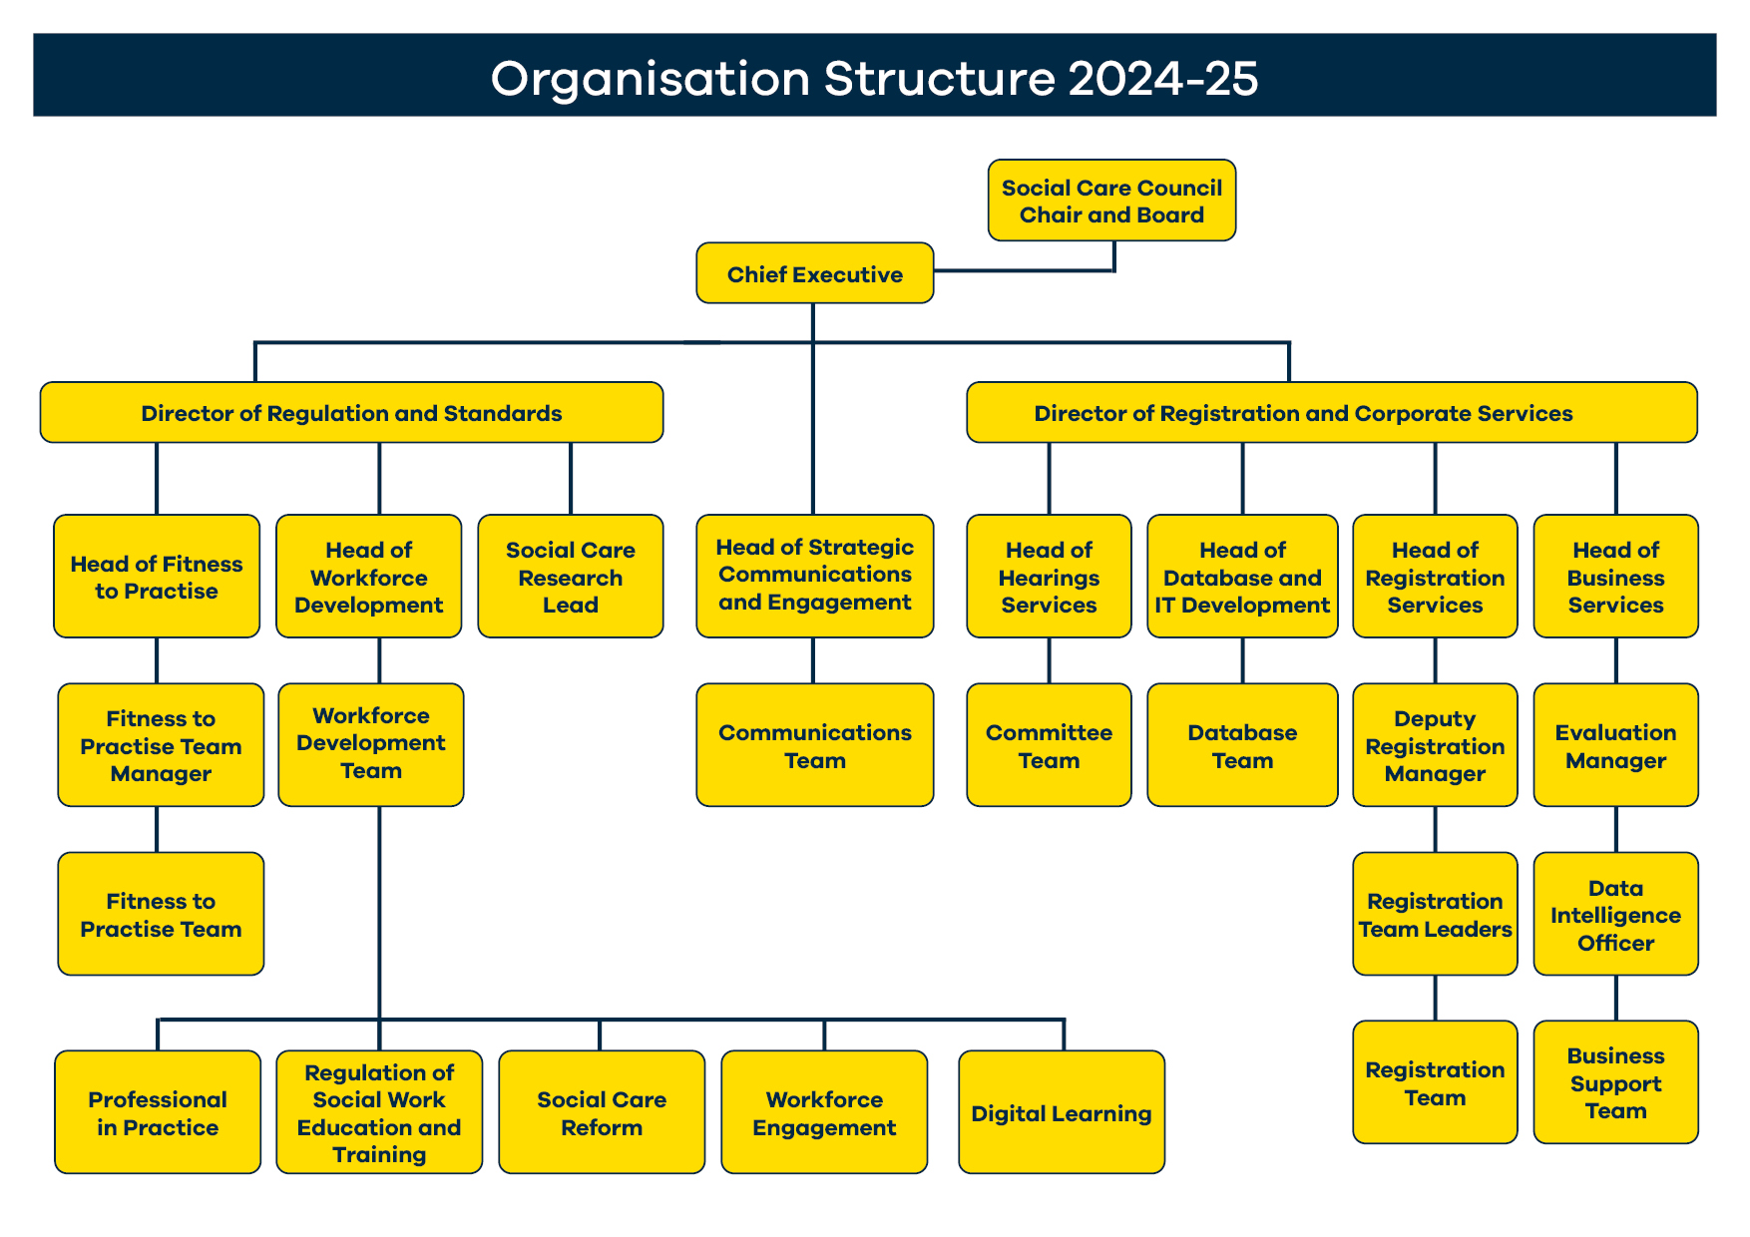

**Glossary of Terms and Abbreviations**

|  |  |
| --- | --- |
| CE | Chief Executive |
| DoH | Department of Health |
| HSC | Health and Social Care |
| HR | Human Resources |
| IIP | Investors in People |
| KPI | Key Performance Indicator |
| OLT | Operational Leadership Team |
| PIP | Professional in Practice |
| PPI | Personal and Public Involvement |
| QI | Quality Improvement |
| SLT | Senior Leadership Team |

1. SMART – Specific, Measurable, Achievable, Realistic and Time-bound