Equality and Disability Action Plans 2023-2028

October 2023

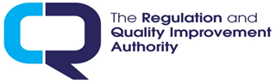



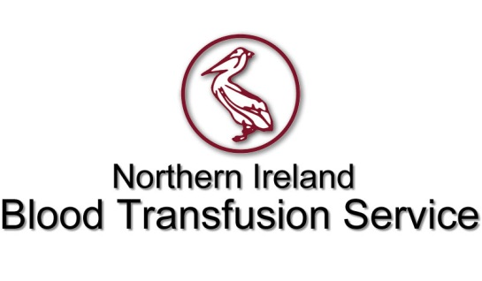

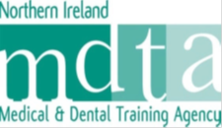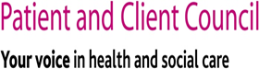

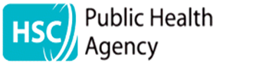

Children’s Court Guardian Agency

for Northern Ireland

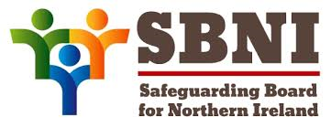

|  |  |
| --- | --- |
| **What is in this document?** | **Page** |
| Accessibility information | 4 |
| What are Equality and Disability Action Plans? | 5 |
| What the law says | 8 |
| How we made our plans | 8 |
| Equality Action Plan | 9 |
| Disability Action Plan | 11 |
| What difference will it make? | 12 |



You can also get a copy of these action plans by looking on the organisations’ websites:

Business Services Organisation <https://bso.hscni.net/directorates/people-and-place/equality-and-human-rights/equality-and-disability-action-plans/>

Public Health Agency <https://www.publichealth.hscni.net/publications/equality-and-disability-action-plans-2023-2028>

Northern Ireland Blood Transfusion Service <https://nibts.hscni.net/wpfb-file/nibts-equality-and-disability-action-plan-2018-2023-final-pdf/>

The Regulation and Quality Improvement Authority [Regulation and Quality Improvement Authority - RQIA](https://www.rqia.org.uk/who-we-are/corporate-documents-(1)/corporate-documents/)

Social Care Council [Equality and Diversity - NISCC](https://niscc.info/equality-and-diversity/)

Patient and Client Council [Equality and Human Rights - Patient and Client Council Northern Ireland (pcc-ni.net)](https://pcc-ni.net/our-work/equality-and-human-rights/)

Children’s Court Guardian Agency for Northern Ireland

<file:///C:/Users/kcoyl009/Downloads/Equality-Disability-Action-Plans-2023_28.pdf>

Northern Ireland Medical and Dental Training Agency <https://www.nimdta.gov.uk/media/bpunej3s/2023_09_28-nimdta-equality-and-disability-action-plans-2023-28-final.pdf>

Northern Ireland Practice and Education Council for Nursing and Midwifery [NIPEC | NIPEC (hscni.net)](https://nipec.hscni.net/)

Safeguarding Board for Northern Ireland <file:///C:/Users/kcoyl009/Downloads/SBNI%20EAP%20DAP%202023-2028.pdf>

You can get a different version of these action plans:

* Paper copy
* Audio
* Large print
* Other languages
* Other formats

by contacting us, the Business Services Organisation

|  |  |
| --- | --- |
| Telephone | Telephone: 028 9536 3961 |
| Text Relay Machine | For Text Relay use 18001 028 9536 3961 |
| open envelope on computer screen | Email: Equality.Unit@hscni.net |

**This book is about our Equality and Disability Action Plans.** It explains what we are going to do over the next 5 years.

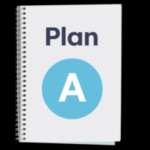

**Equality Action Plan**

This is a plan about what we are going to do about equality. This is to help make things more fair and equal for people in the nine equality groups in the table below.

|  |  |
| --- | --- |
| **Nine Equality Groups** | |
| man and woman smiling and talking | Men and women |
| Four people with various disabilities | Disabled people |
| inclusive picture of five people from different ethnic minorities smiling | People from ethnic minorities. These are people who come from another country or whose families came to Northern Ireland from another country.  It includes Irish Travellers. |
| Left hand picture is a group of four diverse people. Right hand picture is a Muslim woman wearing a hijab talking to a little girl | People with different religions or beliefs |
| left hand picture is two men embracing. Right hand picture is a man and woman holding hands | People who have different sexual orientations. Sexual orientation means a man and woman attracted to each other, two men attracted to each other or two women attracted to each other |
| a ballot box | People with different political views |
| left hand picture is a lady with her daughter wearing glasses. Right hand picture is a lady pushing a girl in a wheelchair | People who care for their children or care for other adults who are sick or have a disability |
| two wedding rings | People who are married, in a civil partnership (between two men or between two women), single, widowed or divorced |
| a baby with down's syndrome, an ethnic minority man and an elderly Caucasian lady | Younger people and older people |

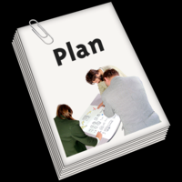

**Disability Action Plan**

This is a plan about what we are going to do to ensure people with a disability are treated fairly and have the same chances as people who don’t have a disability.

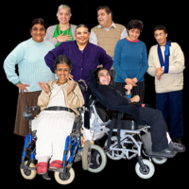

This is to make things better for people with a disability.

**What the law says**

The equality law says that we need to treat people in the 9 groups listed on page 4,5, 6 and 7 fairly.

**WHAT THE LAW SAYS**

The disability law says that we must involve people with different disabilities when we plan and do things. It also says that we must encourage people to think about and treat disabled people in a positive way.

**How we made our plans**

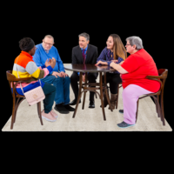

We looked at what we have done so far.

We asked our staff to think about what worked well and what could have worked better.

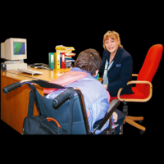For the new plans, we asked them to think about how we can make things better for people who use our services and our staff.

We held meetings with staff to find out what we can do to improve things for our staff with a disability or who look after someone who has a disability.

We held meetings called consultation events where voluntary sector organisations told us what we can do to improve things for our staff with a disability or who look after someone who has a disability and a special meeting with the British Deaf Association (BDA).

**Equality Action Plan 2023-2028**

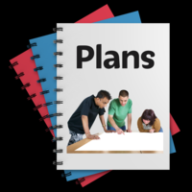

These plans are for the organisations mentioned above who each have their own plans with actions that they have created.

This is a list of what we will do about Equality.

**Accessible communication**

Many of the 10 organisations want to do things to communicate better with people where English is not their first language. They want to do the same for people who have a disability.

For example:



Some people who are training to become doctors have hearing loss; teach staff who are training them about what support people with hearing loss may need. (NIMDTA)

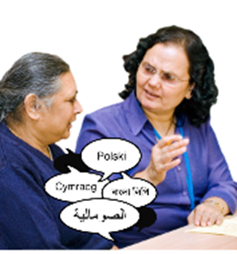

Have an interpreter there when someone whose first language is Polish comes in to give blood. (BTS)

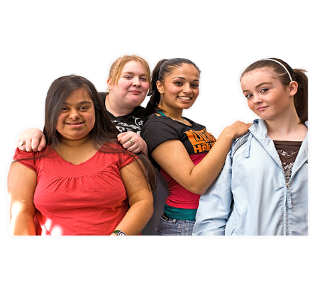

Find a way to ask children and young people about their views when English is not their first language. (CCGANI and SBNI)

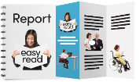

Translate more reports and leaflets into Easy Read and other languages. (PCC)

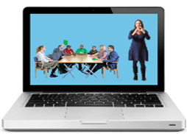

Check what information people who use sign language need and put videos on their website with a person signing this information (BSO and RQIA).

**Equality monitoring**

Some of the organisations have said that they will do more to collect better equality information.

For example:

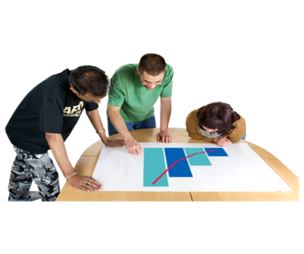

Collect information to find out whether fewer people from some equality groups train to become social workers or social care workers than people from other equality groups. (Social Care Council).

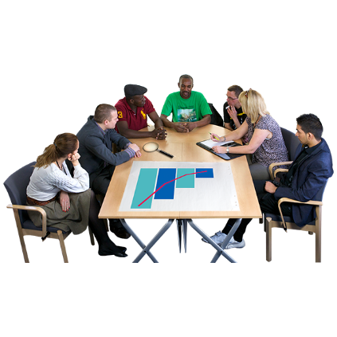

Collect information to find out how many nurses and midwives from ethnic minorities access education at higher levels (called postgraduate education) (NIPEC). This is to see whether new advice that they will produce for nurses and midwives from ethnic minorities will make a difference.

**Engagement**

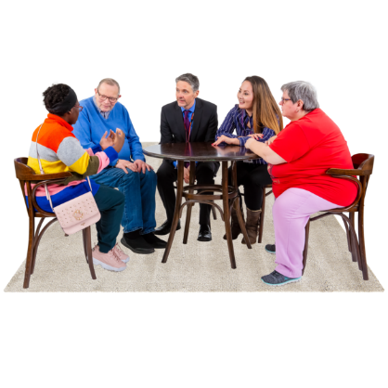

What a lot of organisations have also said that they will do is to reach out to groups of people more who they have had little contact with before.

For example:

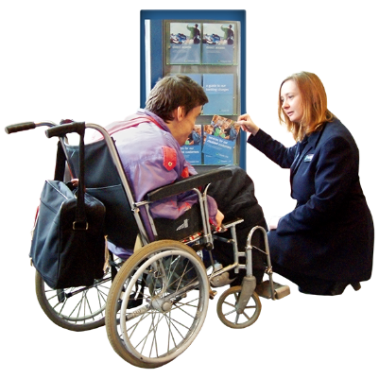

Reach out more to people who are deaf or have hearing loss and organisations who work with them. Do the same with people and organisations who are from ethnic minorities. (PCC)

**Disability Action Plan 2023-2028:**



This is a list of some of what we will do about disability.



We will provide information for staff on certain disabilities. We want all our staff to know more about disabilities.

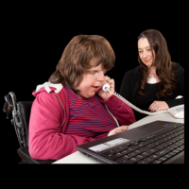

We will offer work placements for disabled people.

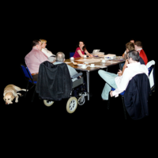

We will encourage our staff to attend our disability staff network meetings.

**What difference will it make?**

**Disability Action Plan**

People who make decisions in our organisations will know more about what it is like for staff who have a disability and what they need to do their jobs.

There will be more support for staff with a disability.

People with disabilities will get a better chance to work with us in work placements.

People with disabilities will have better chances of getting a job with us. More of our staff who become disabled keep working with us.

**Artwork**

Artwork is from the Photo Symbols Easy-Read Library [Welcome to Photosymbols](https://www.photosymbols.com/)