
The Social Care Council Register for
Social Workers
Social Care Workers
Social Work Students

in Northern Ireland


Live Register Report at 30 Jun 2024 (Qtr 1)

Introduction to the Register

The Social Care Council maintains a Register of all Social Workers and Social Care Workers who have been assessed as suitable to practise in Northern Ireland. The Social Care Council also registers all students studying on the Degree in Social Work courses in Northern Ireland. All registrants must meet the Social Care Council Standards for their Conduct and Practice.
The Register is split into three Parts:
- Part 1 is for qualified Social Workers;
- Part 2 is for those in designated Social Care roles covered by compulsory registration;
- The third part of the Register is for Social Work Students.

This report gives a snapshot of the Social Care Council Register on 30 June 2024. which shows a total of 47557 registrants (6596 Social Workers, 40339 Social Care Workers and 622 Social Work Students). It provides an overview of workforce demographics, where they are working and the areas of care in which they are providing services.

The Register experiences minor changes every day as people move in and out of the workforce, or as students join/leave Social Work Degree courses. Currently, the workforce is composed of 84.8% Social Care Workers, 13.9% Social Workers and 1.3% Social Work Students.

 | Register at 30 June 2023 | Register at 30 Jun 2024
Social Workers | 6608 (14.5%) | 6596 (13.9%)
Social Care Workers | 38301 (84.1%) | 40339 (84.8%)
Students | 615 (1.3%) | 622 (1.3%)

Report Overview
Comparative data from previous quarters is included in this report, to analyse trends within the workforce.

Key findings –
  - The Register has grown by 4.9% since Qtr 1 June 2023
  - Social Care Workers have driven the increase in the Register (+5.3%)
  - Specific job roles have seen the most growth ie Adult Residential Care Workers (+7%), Supported Living Workers (+8%) and Domiciliary Care Workers (+5%)
  - The majority of new joiners to the Register are employed in providing services to older people (+12%) and adults with a learning disability (+10%)
  - A decline in Social Workers employed by recruitment agencies (-46%) is observed since Qtr 1 June 2023, the majority of which, have gained employment contracts with the Health & Social Care Trusts.

Maintaining the Register
All registrants and their employers have access to their registration records through the online Registration Portal and the corresponding Employer Portal; and all are encouraged to keep their employment details regularly updated and are reminded to do so at their annual fee payment point. At the end of every registration renewal period (either 3 or 5 years, depending on the registration status), registrants are required to renew their registration. As part of the renewal process, they are asked to confirm that they have the minimum compliance of 90 hours continuous professional development; and review and update their registration record, which helps to provide an insight to the demographics of the registered workforce.
Not everyone on the Register will currently be working, or be practising in the work setting they are registered against. Some may have been redeployed to related roles in Social Care, or perhaps taken a career break for personal or study reasons. Social Care registrants must be employed in social care to remain on the register and social work students must be progressing through their social work degree at a recognised University. Social Work registrants not in employment are permitted to remain on the Register providing they maintain their registration, including continuing with the learning and development requirements for their professional development.

Real-Time Access to Register Information
Following a collaboration with the Department of Health and further Social Care Strategy investment, a new online registration dashboard has been built and is available at this link: Social Care Council Live Register Dashboard.

Size of the Register
On 30 June 2024 (end of Q1) the Register totalled 47557 as outlined in Figure 1 below.
Figure 1
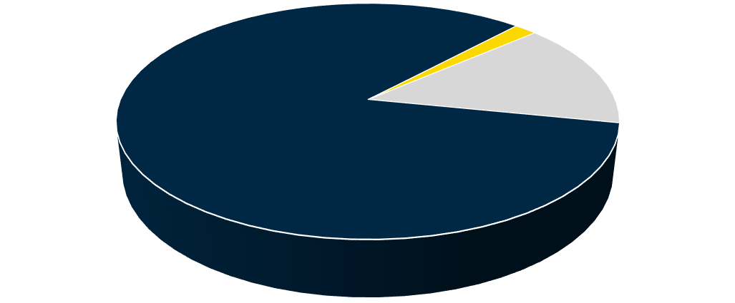
Social Care Council Register Profile
47557 registrants at 30 June 2024

Student, 622

Social Work, 6596
Social Care, 40339

Figure 2 below shows the Register profile trend between Qtr 1 2023/2024 – Qtr 1 2024/2025
The Social Care Council quarter periods run from April to June ( Q1), July to September (Q2), October to December (Q3) and January to March (Q4) each financial year. Whilst a 4.9% increase in the number of registrants is observed between June 2023 and June 2024, the workforce proportions remain consistent. The variation in the figures for registration across months is also influenced by removals for non-payment of fees and the time it takes to re-new and process new applications for registration.
It should also be noted that student numbers will equate to the academic points of graduation and new intakes across the programmes which explains why the numbers vary across periods.
Figure 2
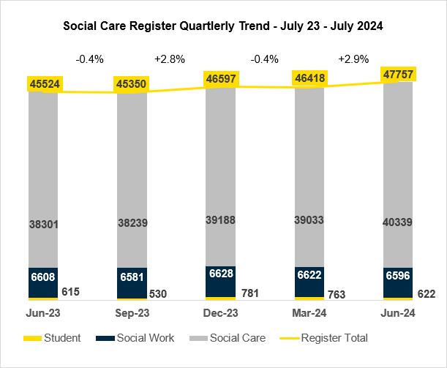

Structure of the Register

Registrants identified themselves across 22 Job Roles (Sub-Parts of the Register) as shown below.
- Sub-Parts of Part 1 of the Register are Qualified Social Workers and Internationally Qualified Social Workers (Social Workers qualified outside of the UK)
- Sub-Parts of Part 2 of the Register are those in designated Social Care Worker roles covered by compulsory registration and also a number of non-mandatory roles agreed with the Council where employers have required their staff to register.
- The third part of the Register is for Social Work Students currently engaged in the Social Work Degree Programme.

In Table 1 below Social Care represents 84.8% of the Register, the most significant groups of Social Care staff identified as Adult Residential Care Workers (35.1%) and Domiciliary Care Workers (31.7%). The next largest groups within Social Care are Supported Living Workers (6.82%) and Day Care Workers (5.12%). These are the mandatory registration groups for social care. These proportions remain in keeping to that observed in the previous quarters for 2023/24. However, the growth in the social care register is mainly due to Adult Residential Care Workers (increased by 6%), Domiciliary Care Workers (increased by 4%) and Supported Living Workers (increased by 8%) joining the register.

Table 1

 | Job Role | Live Count at 30 Jun 2024 | % of the Register
PART 1 | Social Worker
PART 1 | Qualified Social Worker | 6574 | 13.82%
PART 1 | Internationally Qualified Social Worker | 22 | 0.05%
 | Social Work Student | 622 | 1.3%
 | Social Care Worker | 40339 | 84.8%
PART 2 | Adult Residential Care Worker | 16693 | 35.1%
PART 2 | Domiciliary Care Worker | 15076 | 31.7%
PART 2 | Supported Living Worker | 3243 | 6.82%
PART 2 | Day Care Worker | 2437 | 5.12%
PART 2 | Residential Child Care Worker | 695 | 1.46%
PART 2 | Domiciliary Care Manager | 496 | 1.04%
PART 2 | Social Work Assistant | 480 | 1.01%
PART 2 | Youth and Family Support Worker | 460 | 0.97%
PART 2 | Outreach Worker | 258 | 0.54%
PART 2 | Residential Home Manager | 146 | 0.31%
PART 2 | Day Care Centre Manager | 110 | 0.23%
PART 2 | Advocacy Worker | 55 | 0.12%
PART 2 | Personal Advisor | 44 | 0.09%
PART 2 | Residential Family Centre Worker | 43 | 0.09%
PART 2 | Driver | 35 | 0.07%
PART 2 | Rehabilitation Officer for the Blind | 28 | 0.06%
PART 2 | Education Welfare Officer w/o SW Qual | 23 | 0.05%
PART 2 | Environmental Technical Officer | 13 | 0.03%
PART 2 | Education Welfare Officer Manager | 4 | 0.01%

Employment

Employment by Sector

    - The Register is split into four key employment sectors, employment agency, private, voluntary and statutory (including Health and Social Care Trusts, Education, Justice and NDPBs).
    - The Register currently lists 510 employing Organisations across all the sectors.

In table 2 below at 30 June 2024, employment sectors for Social Workers and Social Care Workers continue to show significant differences, as previously reported.
    - The majority of Social Workers are employed within the Statutory Sector i.e. Health and Social Care Trusts (71.63%). As observed in Figure 4b, an increase of 4.1% Social Workers is observed in the Health and Social Care Trusts, since June 2023, mainly due to the decrease of Recruitment Agency contracts and Social Workers now gainfully employed in permanent posts.

    - The majority of Social Care Workers are employed within the Non-Statutory Sector with the largest number employed within the Private Sector (43.88%). At the 30 June 2024, 21.38% are employed by Health and Social Care Trusts. There has been a 5.3% growth in the number of Social Care Workers joining the register, since June 2023, the majority of which are employed in the Private Sector where the Social Care workforce has increased by 14.7%, followed by Recruitment Agencies increasing by 11%, between Qtr 1 June 2023
and Qtr 1 June 2024.

A small percentage of registrants have ‘not given’ recorded against their employer sector. As well as requests to registrants to update their employment which may have changed in period, employing organisations have permission and are encouraged to update the employment part of the records for those registrants who were their employees at a point in time. Both these activities help to increase the accuracy of the employment profile of the register.
Table 2

Employment Sector | % of Social Workers | % of Social Care  Workers
HSC Trust | 71.63% | 21.38%
Private Sector | 1.49% | 43.88%
Voluntary Sector | 6.81% | 16.79%
Recruitment/Employment Agency | 1.23% | 12.46%
FE/HE Education | 3.82% | 0.08%
Government | 1.9% | 0.01%
Justice | 4.17% | 0.1%
Not Available | 4.64% | 5.09%
Other | 0.92% | 0.3%
Regulation/Inspection | 0.62% | 0%
Self Employed | 1.12% | 0.01%
Unemployed | 1.65% | 0.17%

Figure 3a Figure 3b
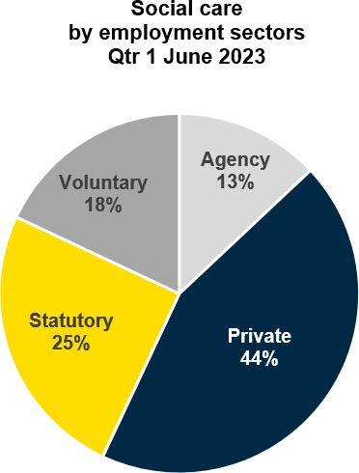
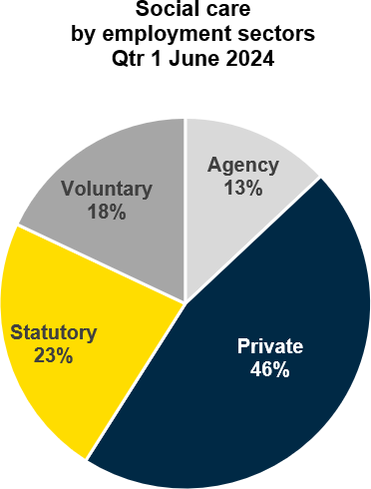

Figure 4a Figure 4b
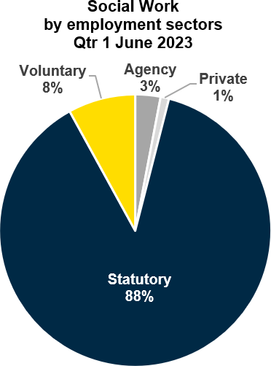
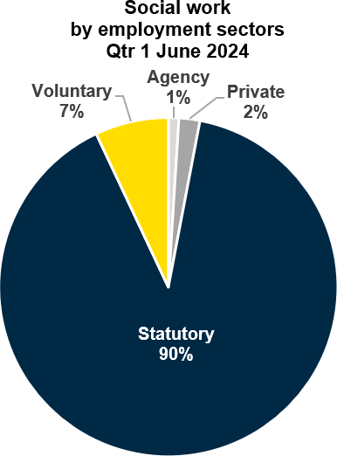

Second Employments
The Register includes information regarding Social Workers and Social Care Workers who have declared that they work in more than one Social Care job role. 40 Social Work Students also indicated they were registered to work in Social Care whilst studying for the Degree in Social Work. These figures remain similar to that reported in previous quarters for 2023/24.
- Social Care Workers 4794 (12%)
- Social Workers 418 (6%)
- Social Work Students 40 (6%)

Social Workers – Employment by Work Focus
Social Worker ‘work focus’ provides an indication of the area of care and groups of people they provide services for as part of their job role. There are currently 30 different types of work focus recorded for Social Workers.

In Figure 5 below analysis of Social Worker data for work focus1 shows that the greatest number of Social Workers (26.2%) work in services for Family & Child care, this includes Family Intervention and Looked After Children teams. The next largest work focus group (9.9%) are working in services for Older People.
Figure 5
Looked After Children Family Intervention
Older People Mental Health/Addiction
Not Available
Other Adult's Learning Disability Adoption/Fostering Training/Education/Governance
Justice/Criminal Children's Disability Adult Disability
Child and Adolescent Mental Health Service
Primary Care Education Welfare
Acute Adult Physical Health
Early Years Adult Safeguarding Children's Learning Disability
Care Management Dementia/EMI Justice/Youth Specialist Centre Homelessness Sensory Services Justice/Restorative Service Development
Children's Physical Health
13.2%
13%
9.9%
8.1%
7.2%
7%
5%
4.9%
3.5%
3.4%
2.5%
2.5%
2.5%
2.4%
2.3%
1.9%
1.5%
1.3%
1.1%
1.1%
0.9%
0.9%
0.7%
0.7%
0.7%
0.5%
0.5%
0.4%
0.2%

Social Care Workers – Employment by Work Focus
Social Care Worker ‘work focus’ provides an indication of the area of care and groups of people they provide services for as part of their job role. There are currently 28 different types of work focus recorded for Social Care Workers.
In Figure 6 below analysis of Social Care Worker data for work focus shows that the greatest number of Social Care Workers (38.63%) work in services for Older People. The next largest work focus group (13.68%) are working in services for Adults with a Learning Disability.
These proportions of Social Care Workers’ work focus groups remain in keeping with reporting in previous quarters for 2023/24. However, the increase in the register from June 2023 are

1 7.2% of Social Workers have not specified their work focus as this level of detail was not required when Social Worker registration was first introduced. This
information is being requested as Social Workers complete their 3-year renewal of registration or when they enrol in the Professional in Practice Framework (PiP) for their CPD.

mainly those social care registrants whose focus of employment is services to older people (increased by 12%) and adult learning disability (increased by 10%).
Figure 6
Older People Adult's Learning Disability
Not Available Dementia/EMI
Adult Physical Health
Other Adult Disability
Mental Health/Addiction
Primary Care Adult Safeguarding Care Management Homelessness Looked After Children
Acute Children's Learning Disability
Family Intervention Community Development Children's Disability
Child and Adolescent Mental Health Service
Sensory Services Justice/Youth Early Years Specialist Centre
Training/Education/Governance
Adoption/Fostering Justice/Criminal Education Welfare Children's Physical Health Justice/Restorative
Service Development
38.63%
13.68%
7.49%
6.52%
5.42%
5.4%
4.68%
3.29%
3.13%
2.83%
2.28%
1.45%
1.43%
0.71%
0.64%
0.58%
0.41%
0.34%
0.21%
0.15%
0.13%
0.09%
0.09%
0.08%
0.08%
0.06%
0.06%
0.06%
0.04%
0.02%

Social Workers – Engagement in the Professional in Practice (PiP) Framework for Social Worker CPD
Social Workers are required to complete 90 hours of Continuous Professional Development (CPD) during every three-year registration period. The PiP Framework provides certificated recognition of competence across the professional spectrum, providing a range of pathways to support Social Workers’ in meeting the requirements for their on-going learning and development. Currently, engagement in PiP activity is compulsory for newly qualified Social Workers who are required to complete PiP requirements within the professional Consolidation Award following completion of their Assessed Year in Employment. 58% of Social Workers on the live Register have achieved or are working towards awards within the PiP Framework to fulfil their CPD requirements.

Table 3

PiP Engagement

Award Status | Social Workers on the Live Register
1 Achieved Award | 38%
2 Waiting Award | <1%
3 In Progress | 19%
4 Withdrawn from Award | 21%
5 No PIP Engagement | 20%

Of those Social Workers on the Register who have completed Awards, 23% hold the NI Consolidation Award, 24% hold the NI Specialist Award and 4% hold the NI Leadership & Strategic Award. 3 Social Workers hold the PiP Advanced Scholarship Award.
The employment sectors for Social Workers holding awards are closely matched to the proportion of registered Social Workers employed in each of these sectors. 75% are employed in Health and Social Care Trusts, 6% are employed in the Voluntary Sector, 3% in Justice and 5% in Education.

Workforce Age and Gender
As reported in Figure 8a & 8b below for June 2024, Social Work and Social Care show similar patterns in gender split, with 84% of the workforce identifying as female. Representation across the age bands remains steady, with 36% of Social Workers and 50% of Social Care Workers in the under 40 age bands. This proportion is in keeping with Qtr 1 June 2023.
Figure 7a Figure 7b
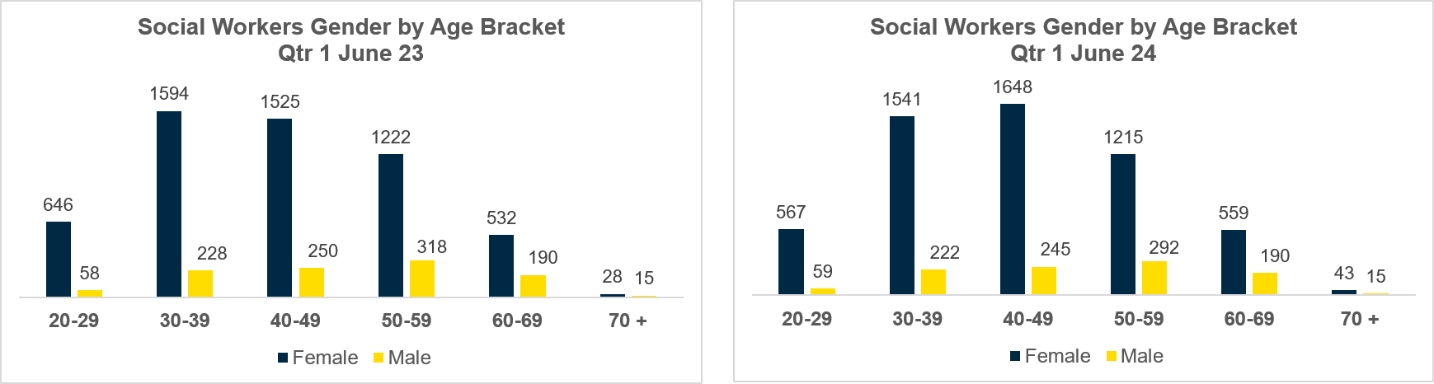
Figure 8a Figure 8b
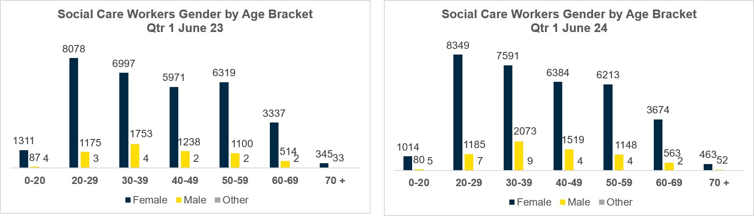

5 Conclusion
In conclusion, as of Qtr 1 June 2024, the Social Work and Social Care register has seen a significant increase of 1339 registrants (2.9%) from the previous quarter ending 31 March 2024. 246 students qualified as Social Workers during the summer and while a number of them transferred off the student part of the register by the end of Qtr 1, as they reach their academic graduation point in social work, the overall register increase is due to a 3.3% rise in the number of Social Care Workers joining the register.
The register has increased by 4.9% over the last year since June 2023 and this growth is driven by the addition of 2038 Social Care Workers, reflecting a 5.3% increase in the number of Social Care Workers in the last year. The register has welcomed a notable influx of Social Care Workers into specific job categories: 1084 Adult Residential Care Workers (7% increase), 653 Domiciliary Care Workers (5% increase) and 250 Supported Living Workers (8% increase).
Particularly encouraging is the trend of younger individuals joining the workforce, with the majority of new registrants under the age of 40, including a third, under the age of 20.
Social Care represents the largest segment of the Register, with Adult Residential Care Workers and Domiciliary Care Workers being the most prominent groups. Employment sectors also remain consistent, with the majority of Social Workers employed in the Statutory Sector (such as Health and Social Care Trusts), while Social Care Workers are employed across various sectors, primarily the Private Sector.
The primary focus of Social Workers continues to be on Family & Child Care services indicating their crucial role in supporting vulnerable families and children. Services for Older People also remain a significant focus for Social Workers. Similarly, for Social Care Workers the main emphasis continues to be on services for Older People, followed by a notable proportion dedicated to working with Adults with Learning Disabilities. The engagement with the PiP Framework for Continuous Professional Development shows a significant proportion of Social Workers participating in learning that is assessed against professional standards, and in many cases, academic quality benchmarks.
Overall, the number of registrants, employment sectors, work focus areas, and gender distribution show no significant deviations from Qtr 1 & Qtr 4 2023/2024 , indicating a stable landscape within the profession. These findings contribute to a comprehensive understanding of the profession and its dynamics, providing stakeholders with valuable information for decision making and resource allocation.

Authors | Contact Details
Elizabeth Moore – Information Analytics & Intelligence Officer | D: 028 95 362 673  Email: elizabeth.moore@niscc.hscni.net

