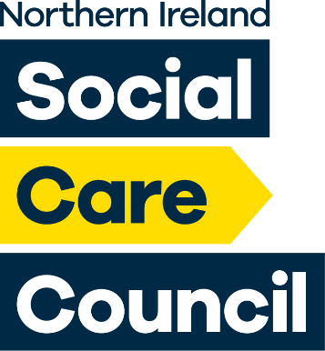

The Social Care
Council Register for
Social Workers
Social Work Students

Social Care Practitioners


in Northern Ireland

Live Register Report at 31 Dec 2025 (Qtr 3)

Introduction to the Register

The Social Care Council maintains a Register of all Social Workers and Social Care Practitioners (previously referred to as Social Care Workers) who have been assessed as suitable to practise in Northern Ireland. The Social Care Council also registers all students studying on the Degree in Social Work courses in Northern Ireland. All registrants must meet the Social Care Council Standards for their Conduct and Practice.

The Register is split into three Parts:
- Part 1 is for qualified Social Workers;
- Part 2 is for those in designated Social Care roles covered by compulsory registration;
- The third part of the Register is for Social Work Students.

This report gives a snapshot of the Social Care Council Register on 31 Dec 2025. which shows a total of 49503 registrants (6912 Social Workers, 41720 Social Care Practitioners and 871 Social Work Students). It provides an overview of workforce demographics, where they are working and the areas of care in which they are providing services.

The Register experiences minor changes every day as people move in and out of the workforce, or as students join/leave Social Work Degree courses. Currently, the workforce is composed of 84.3% Social Pare practitioners, 13.9% Social Workers and 1.8% Social Work Students.

 | Register at 31 Dec 2024 | Register at 31 Dec 2025
Social Workers | 6772 (14%) | 6912 (13.9%)
Social Care Practitioners | 40808 (84.3%) | 41720 (84.3%)
Students | 829 (1.7%) | 871 (1.8%)

Report Overview
Comparative data from previous quarters is included in this report, to analyse trends within the workforce.

- The Register has grown by 2.3% since Qtr 3 Dec 2024.

- Social Care Practitioners have driven the increase in the Register (+2.2%) since Qtr 3 Dec 2024.

- Specific job roles have seen the most growth since Qtr 3 Dec 2024, ie Adult Residential Care Workers (+2.4%), Supported Living Workers (5.7%) and Home Care Workers (+1.1%).

- The majority of new joiners to the Register are employed in providing services to older people (+3.4%) and adults with a learning disability (+3.1%).

Maintaining the Register
All registrants and their employers have access to their registration records through the online Registration Portal and the corresponding Employer Portal; and all are encouraged to keep their employment details regularly updated and are reminded to do so at their annual fee payment point. At the end of every registration renewal period (either 3 or 5 years, depending on the registration status), registrants are required to renew their registration. As part of the renewal process, they are asked to confirm that they have the minimum compliance of 90 hours continuous professional development; and review and update their registration record, which helps to provide an insight to the demographics of the registered workforce.
Not everyone on the Register will currently be working, or be practising in the work setting they are registered against. Some may have been redeployed to related roles in Social Care, or perhaps taken a career break for personal or study reasons. Social Care registrants must be employed in social care to remain on the register and social work students must be progressing through their social work degree at a recognised University. Social Work registrants not in employment are permitted to remain on the Register providing they maintain their registration, including continuing with the learning and development requirements for their professional development.
Real-Time Access to Register Information
Following a collaboration with the Department of Health and further Social Care Strategy investment, an online real-time registration dashboard has been built which provides monthly snapshots from November 2021 and built in analytics to support research and decision making. The dashboard is open access and is available at this link : Social Care Council Live Register Dashboard.

1. Size of the Register
On 31 Dec 2025 (end of Q3) the Register totalled 49503 as outlined in Figure 1 below.
Figure 1

Figure 2a below shows the Register profile trend between Qtr 3 2024/2025 – Qtr 3 2025/2026
The Social Care Council quarter periods run from April to June ( Q1), July to September (Q2), October to December (Q3) and January to March (Q4) each financial year. The variation in the figures for registration across months is also influenced by removals for non-payment of fees and the time it takes to re-new and process new applications for registration.
It should also be noted that student numbers will equate to the academic points of graduation and new intakes across the programmes which explains why the numbers vary across periods

Figure 2a
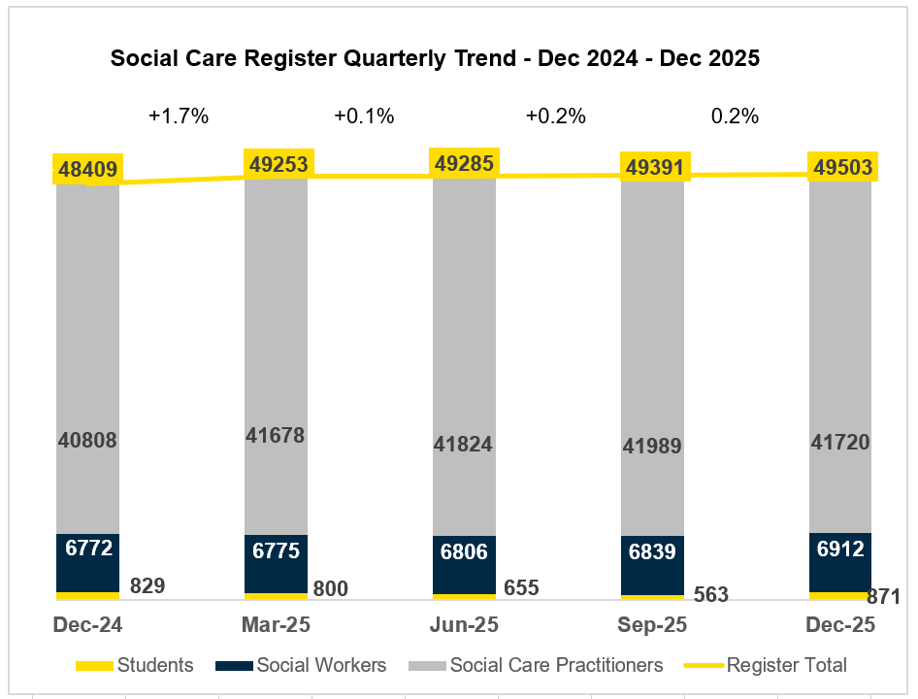

Figure 2b shows a 14.9% increase in the number of registrants observed between Qtr 4 March 2022 and Qtr 4 March 2025, an average of 5% per year. Across these years, the workforce proportions are consistent. At Qtr 4 March 21 the implementation of the emergency social care register and the temporary pause in removal of registrants, to support the social care workforce during the covid-19 pandemic, results in a higher than normal register number.
.

Figure 2b
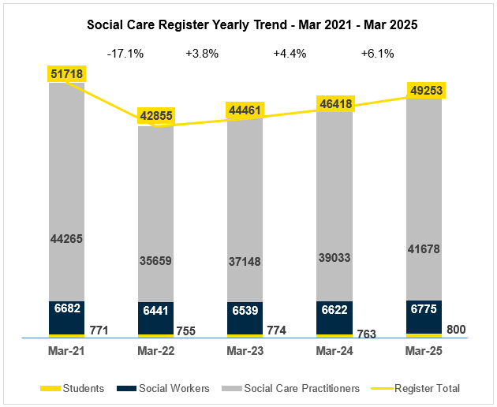

2. Structure of the Register
Registrants identified themselves across 22 Job Roles (Sub-Parts of the Register) as shown below.
- Sub-Parts of Part 1 of the Register are Qualified Social Workers and Internationally Qualified Social Workers (Social Workers qualified outside of the UK)
- Sub-Parts of Part 2 of the Register are those in designated Social Care Worker roles covered by compulsory registration and also a number of non-mandatory roles agreed with the Council where employers have required their staff to register.
- The third part of the Register is for Social Work Students currently engaged in the Social Work Degree Programme.

In Table 1 below Social Care represents 84.27 % of the Register, the most significant groups of Social Care staff identified as Adult Residential Care Workers (35.05%) and Home Care Workers (30.96%). The next largest groups within Social Care are Supported Living Workers (7.11%) and Day Care Workers (5.02%). These are the mandatory registration groups for social care. These proportions remain in keeping to that observed in the previous quarters for 2025/26. However, the growth in the social care register since Qtr 3 Dec 2024, is mainly due to Adult Residential Care Workers (increased by 2.4%), Home Care Workers (increased by 1.1%) and Supported Living Workers (increased by 5.7%) joining the register.

Table 1
 | Job Role | Live Count  at 31 Dec 2025 | % of the Register
PART 1 | Social Worker
PART 1 | Qualified Social Worker | 6912 | 13.96%
 | Social Work Student | 871 | 1.76%
 | Social Care Practitioner | 41720 | 84.28%
PART 2 | Adult Residential Care Worker | 17352 | 35.05%
PART 2 | Home Care Worker | 15329 | 30.96%
PART 2 | Supported Living Worker | 3519 | 7.11%
PART 2 | Day Care Worker | 2485 | 5.02%
PART 2 | Residential Child Care Worker | 763 | 1.54%
PART 2 | Social Work Assistant | 505 | 1.02%
PART 2 | Home Care Manager | 500 | 1.01%
PART 2 | Youth and Family Support Worker | 483 | 0.98%
PART 2 | Outreach Worker | 281 | 0.57%
PART 2 | Residential Home Manager | 158 | 0.32%
PART 2 | Day Care Centre Manager | 114 | 0.23%
PART 2 | Personal Advisor | 55 | 0.11%
PART 2 | Advocacy Worker | 46 | 0.09%
PART 2 | Residential Family Centre Worker | 37 | 0.07%
PART 2 | Driver | 31 | 0.06%
PART 2 | Rehabilitation Officer for the Blind | 28 | 0.06%
PART 2 | Education Welfare Officer w/o SW Qual | 20 | 0.04%
PART 2 | Environmental Technical Officer | 9 | 0.02%
PART 2 | Education Welfare Officer Manager | 5 | 0.01%

3. Employment

3.1 Employment by Sector

- The Register is split into four key employment sectors, employment agency, private, voluntary and statutory (including Health and Social Care Trusts, Education, Justice and NDPBs).

- The Register currently lists 510 employing Organisations across all the sectors.

In table 2 below at 31 Dec 2025, employment sectors for Social Workers and Social Care Practitioners continue to show significant differences, as previously reported.
The majority of Social Workers are employed within the Statutory Sector i.e. Health and Social Care Trusts (73.12%). As observed in Figure 4b, an increase of 5% Social Workers is observed in the Health and Social Care Trusts, since Qtr 3 Dec 2024. This is mainly due to Social Work students now graduated and transferring to Part 1 of the Register and the decrease of Recruitment Agency contracts where Social Workers are now gainfully employed in permanent or temporary posts.

The majority of Social Care Practitioners are employed within the Non-Statutory Sector with the largest number employed within the Private Sector (44.38%). At the 31 Dec 2025, 20.84% are employed by Health and Social Care Trusts. There has been a 2.2% growth in the number of Social Care Practitioners joining the register, since Qtr 3 Dec 2024, the majority of which are employed in the Private Sector.

A small percentage of registrants have ‘not given’ recorded against their employer sector. As well as requests to registrants to update their employment which may have changed in period, employing organisations have permission and are encouraged to update the employment part of the records for those registrants who were their employees at a point in time. Both these activities help to increase the accuracy of the employment profile of the register.
Table 2
Employment Sector | % of Social Workers | % of Social Care Practitioners
HSC Trust | 73.12 % | 20.84%
Private Sector | 1.64% | 44.38%
Voluntary Sector | 6.29% | 16.17%
Recruitment/Employment Agency | 0.45% | 12.03%
FE/HE Education | 3.75% | 0.07%
Government | 2.07% | <0.01%
Justice | 4.45% | 0.13%
Other | 1.2% | 0.04%
Regulation/Inspection | 0.69% | <0.01%
Self Employed | 1.22% | 0.01%
Unemployed | 2.16% | 0.09%

Figure 3a Figure 3b
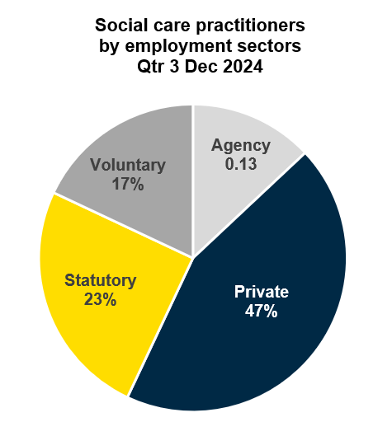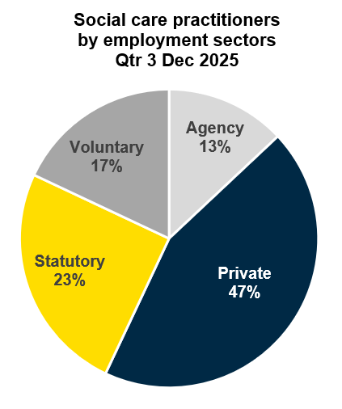

Figure 4a Figure 4b
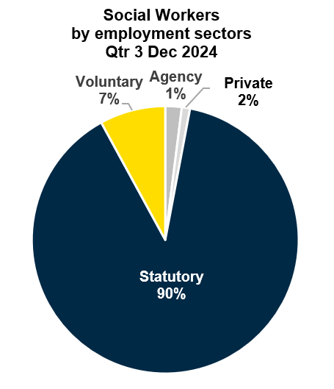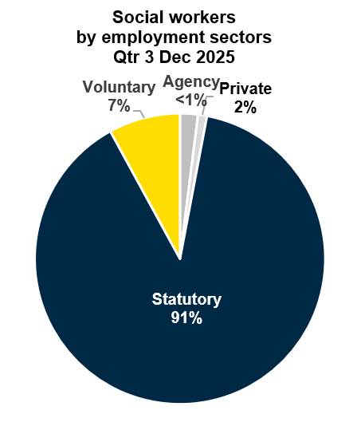

3.2 Social Workers – Employment by Work Focus
Social Worker ‘work focus’ provides an indication of the area of care and groups of people they provide services for as part of their job role. There are currently 30 different types of work focus recorded for Social Workers.

In Figure 5 below analysis of Social Worker data for work focus shows that the greatest number of Social Workers (26.34%) work in services for Family & Child care, this includes Family Intervention and Looked After Children teams. The next largest work focus group (10.3%) are working in services for Older People.
Figure 5
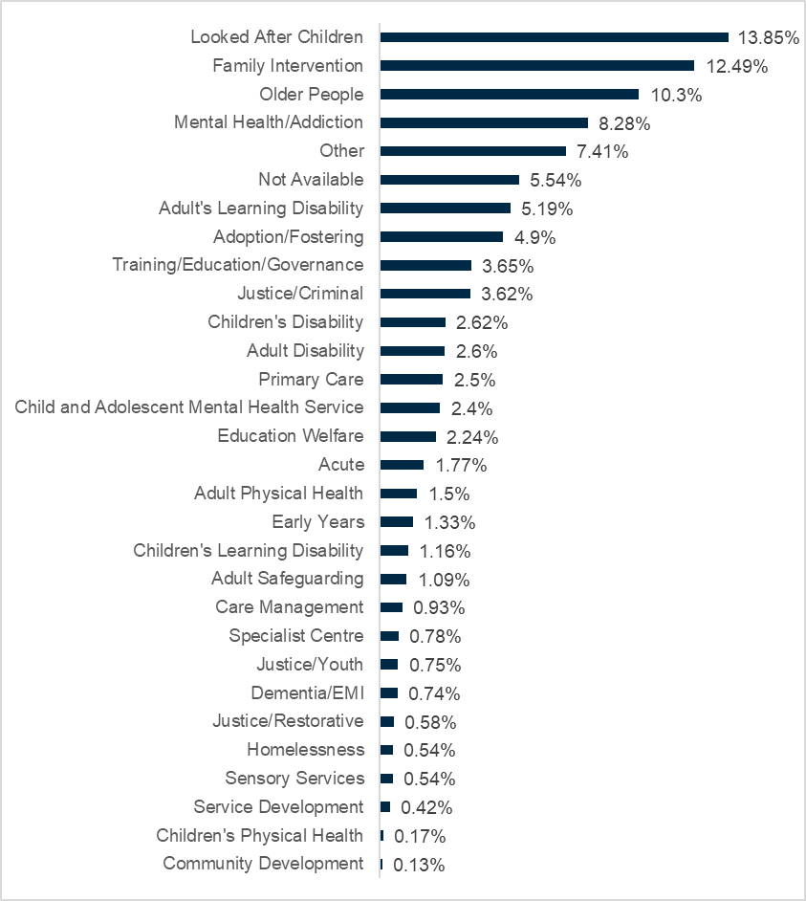

3.3 Social Care Practitioners – Employment by Work Focus
Social Care Practitioner ‘work focus’ provides an indication of the area of care and groups of people they provide services for as part of their job role. There are currently 28 different types of work focus recorded for Social Care Practitioners.
In Figure 6 below analysis of Social Care Practitioner data for work focus shows that the greatest number of Social Care Practitioners (39.3%) work in services for Older People. The next largest work focus group (13.91%) are working in services for Adults with a Learning Disability.
These proportions of Social Care Practitioners’ work focus groups remain in keeping with reporting in previous quarters for 2025/26. However, the increase in the register from Qtr 3 Dec 2024 are mainly those social care registrants whose focus of employment is services to older people (increased by 3.4%) and adult learning disability (increased by 3.1%).
Figure 6
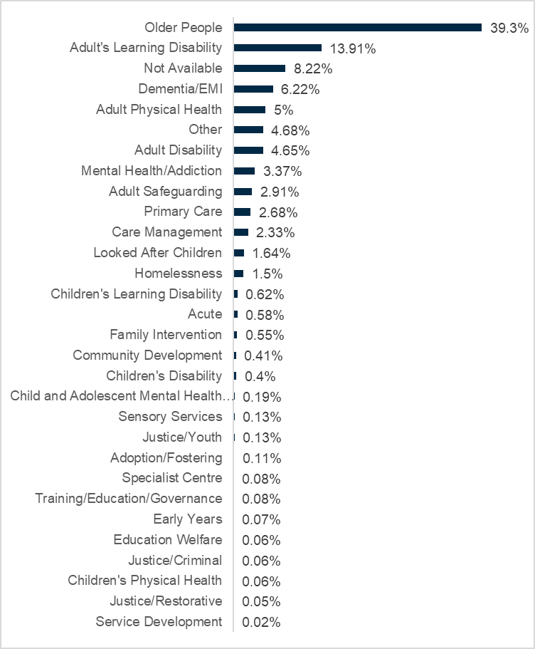

3.4 Social Workers – Engagement in the Professional in Practice (PiP) Framework for Social Worker CPD
Social Workers are required to complete 90 hours of Continuous Professional Development (CPD) during every three-year registration period. The PiP Framework provides certificated recognition of competence across the professional spectrum, providing a range of pathways to support Social Workers’ in meeting the requirements for their on-going learning and development. Currently, engagement in PiP activity is compulsory for newly qualified Social Workers who are required to complete PiP requirements within the professional Consolidation Award following completion of their Assessed Year in Employment. 56% of Social Workers on the live Register have achieved or are working towards awards within the PiP Framework to fulfil their CPD requirements.
Table 3
Award Status | Social Workers on the Live Register
1 Achieved Award | 39%
2 Waiting Award | <1%
3 In Progress | 16%
4 Withdrawn from Award | 26%
5 No PIP Engagement | 18%
PiP Engagement

Of those Social Workers on the Register who have completed Awards, 23% hold the NI Consolidation Award, 29% hold the NI Specialist Award and 4% hold the NI Leadership & Strategic Award. 5 Social Workers hold the PiP Advanced Scholarship Award.
The employment sectors for Social Workers holding awards are closely matched to the proportion of registered Social Workers employed in each of these sectors. 76% are employed in Health and Social Care Trusts, 6% are employed in the Voluntary Sector, 4% in Justice and 4% in Education.
4. Workforce Age and Gender
As reported in Figure 7b & 8b below for Qtr 3 Dec 2025, Social Work and Social Care show similar patterns in gender split, with 83% of the workforce identifying as female. Representation across the age bands remains steady, with 33% of Social Workers and 49% of Social Care Practitioners in the under 40 age bands. This proportion is in keeping with Qtr 3 Dec 2024.

Figure 7a Figure 7b
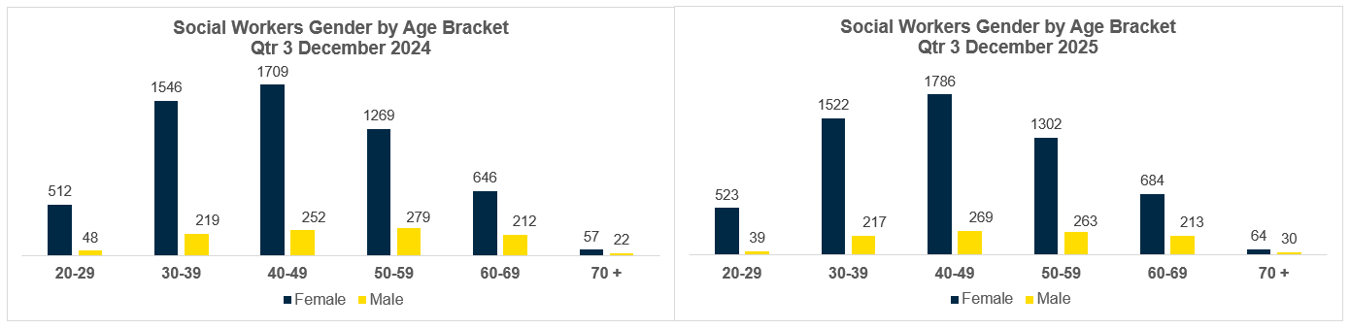

Figure 8a Figure 8b
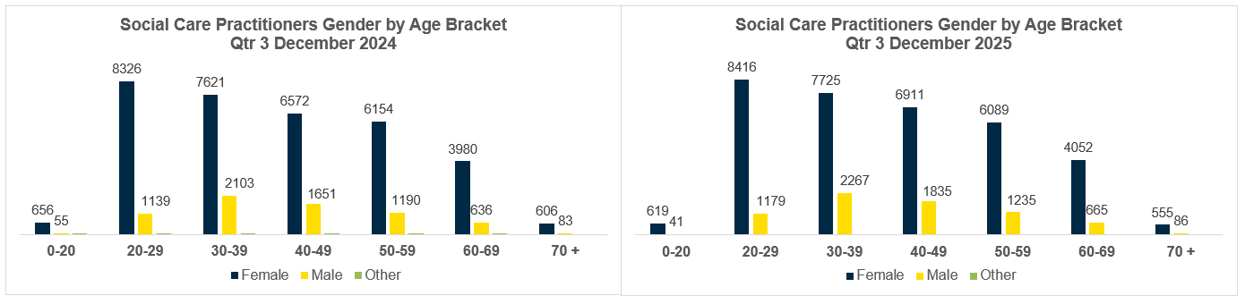
5 Conclusion
In conclusion, during Qtr 2 Sept 2025, the Social Work and Social Care register experienced a marginal increase of 0.2% to 49391, and during Qtr 3 Dec 2025, again saw a marginal increase of 0.2% to 49503.
The register has increased by 2.3% over the last year since Dec 2024 and this growth is driven by the addition of 912 Social Care Practitioners, reflecting a 2.2% increase in the number of Social Care Practitioners in the last year. The register has welcomed a notable influx of Social Care Practitioners into specific job categories: 399 Adult Residential Care Workers (2.4% increase), 172 Home Care Workers (1.1% increase) and 190 Supported Living Workers (5.7% increase).
Particularly encouraging is the trend of younger people in the workforce, 47% of which are under the age of 40.
Social Care represents the largest segment of the Register, with Adult Residential Care Workers and Home Care Workers being the most prominent groups. Employment sectors also remain consistent, with the majority of Social Workers employed in the Statutory Sector (such as Health and Social Care Trusts), while Social Care Practitioners are employed across various sectors, primarily the Private Sector, where the majority of the newly registered Social Care workforce are employed.
The primary focus of Social Workers continues to be on Family & Child Care services indicating their crucial role in supporting vulnerable families and children. Services for Older People also remain a significant focus for Social Workers. Similarly, for Social Care Practitioners the main emphasis continues to be on services for Older People, followed by a notable proportion dedicated to working with Adults with Learning Disabilities. The engagement with the PiP Framework for Continuous Professional Development shows a significant proportion of Social Workers participating in learning that is assessed against professional standards, and in many cases, academic quality benchmarks.
Overall, the number of registrants, employment sectors, work focus areas, and gender distribution show no significant deviations from Qtr 3 2024/2025 and Qtr 2 2025/2026 , indicating a stable landscape within the profession. These findings contribute to a comprehensive understanding of the profession and its dynamics, providing stakeholders with valuable information for decision making and resource allocation.
Author: Elizabeth Moore – Information Analytics & Intelligence Officer | Contact Details: Elizabeth.moore@niscc.hscni.net

5.5% of Social Workers have not specified their work focus as this level of detail was not required when Social Worker registration was first introduced. This information is being requested as Social Workers complete their 3-year renewal of registration or when they enrol in the Professional in Practice Framework (PiP) for their CPD.

