

The Social Care
Council Register for
Social Workers
Social Work Students

Social Care Practitioners


in Northern Ireland

Live Register Report at 31 Mar 2026 (Qtr 4)

Introduction to the Register

The Social Care Council maintains a Register of all Social Workers and Social Care Practitioners (previously referred to as Social Care Workers) who have been assessed as suitable to practise in Northern Ireland. The Social Care Council also registers all students studying on the Degree in Social Work courses in Northern Ireland. All registrants must meet the Social Care Council Standards for their Conduct and Practice.

The Register is split into three Parts:
- Part 1 is for qualified Social Workers;
- Part 2 is for those in designated Social Care roles covered by compulsory registration;
- The third part of the Register is for Social Work Students.

This report gives a snapshot of the Social Care Council Register on 31 Mar 2026. which shows a total of 49597 registrants (6900 Social Workers, 41841 Social Care Practitioners and 856 Social Work Students). It provides an overview of workforce demographics, where they are working and the areas of care in which they are providing services.

The Register experiences minor changes every day as people move in and out of the workforce, or as students join/leave Social Work Degree courses. Currently, the workforce is composed of 84.3% Social Pare practitioners, 13.9% Social Workers and 1.8% Social Work Students.

 | Register at 31 Mar 2025 | Register at 31 Mar 2026
Social Workers | 6775 (13.7%) | 6900(13.9%)
Social Care Practitioners | 41678 (84.6%) | 41841 (84.3%)
Students | 800 (1.6%) | 856 (1.8%)

Maintaining the Register
All registrants and their employers have access to their registration records through the online Registration Portal and the corresponding Employer Portal; and all are encouraged to keep their employment details regularly updated and are reminded to do so at their annual fee payment point. At the end of every registration renewal period (either 3 or 5 years, depending on the registration status), registrants are required to renew their registration. As part of the renewal process, they are asked to confirm that they have the minimum compliance of 90 hours continuous professional development; and review and update their registration record, which helps to provide an insight to the demographics of the registered workforce.
Not everyone on the Register will currently be working, or be practising in the work setting they are registered against. Some may have been redeployed to related roles in Social Care, or perhaps taken a career break for personal or study reasons. Social Care registrants must be employed in social care to remain on the register and social work students must be progressing through their social work degree at a recognised University. Social Work registrants not in employment are permitted to remain on the Register providing they maintain their registration, including continuing with the learning and development requirements for their professional development.

Real-Time Access to Register Information
Following a collaboration with the Department of Health and further Social Care Strategy investment, an online real-time registration dashboard has been built which provides monthly snapshots from November 2021 and built in analytics to support research and decision making. The dashboard is open access and is available at this link : Social Care Council Live Register Dashboard.
Executive Summary
The Northern Ireland social care workforce continues to demonstrate stability and modest growth, with the Register increasing by 0.7% over the year to 49,597 registrants at 31 March 2026. Social Care Practitioners remain the largest staff group, accounting for over 84% of the workforce, while Social Workers represent almost 14% of all registrants. Workforce growth has been driven primarily by increases in Adult Residential Care and Supported Living roles, reflecting continued demand across adult social care services.
Analysis of employment sectors highlights two distinct workforce models. Social Workers are increasingly concentrated within statutory services, with HSC Trust employment rising from 69.2% in 2023 to 74.4% in 2026, alongside a substantial reduction in agency employment. In contrast, Social Care Practitioners continue to be primarily employed in the independent sector, with almost two-thirds working within private and voluntary organisations. These trends suggest increasing workforce stability within social work services and continued reliance on independent sector provision to deliver social care services across Northern Ireland.

Key Highlights
- The Register increased by 0.7% during 2025/26, reaching 49,597 registrants, with growth primarily driven by Social Care Practitioner registrations.
- HSC Trusts strengthened their position as the principal employer of Social Workers, increasing from 69.2% in March 2023 to 74.4% in March 2026.
- Agency employment among Social Workers reduced from 2.3% to 0.4% over the four-year period, indicating improved workforce stability and reduced dependence on temporary staffing arrangements.
- Social Care Practitioners remain predominantly employed in the independent sector, with the private and voluntary sectors accounting for more than 60% of employment in 2026.
- Workforce growth continues to be concentrated in adult services, particularly services for Older People and Adults with Learning Disabilities, reflecting ongoing demographic and service pressures.

1. Size of the Register
On 31 Mar 2026 (end of Q4) the Register totalled 49597 as outlined in Figure 1 below.
Figure 1

Figure 2a below shows the Register profile trend between Qtr 4 2024/2025 – Qtr 4 2025/2026
The Social Care Council quarter periods run from April to June ( Q1), July to September (Q2), October to December (Q3) and January to March (Q4) each financial year. The variation in the figures for registration across months is also influenced by removals for non-payment of fees and the time it takes to re-new and process new applications for registration.
It should also be noted that student numbers will equate to the academic points of graduation and new intakes across the programmes which explains why the numbers vary across periods.
_{Figure 2a}
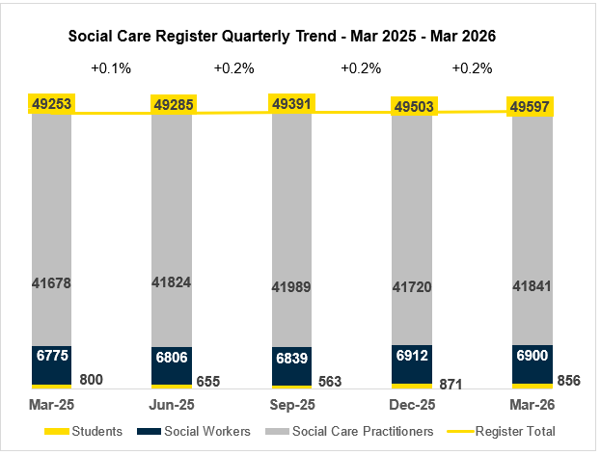

The data shows that the workforce is consistently dominated by Social Care Practitioners, who account for over four-fifths of all registrants across the period. Their numbers increase steadily from 37,148 (83.6%) in Q4 2023 to 41,841 (84.3%) in Q4 2026, indicating sustained growth alongside a stable proportional share. Social Workers also increase in number, rising from 6,539 to 6,900 over the same period; however, their proportion of the workforce declines slightly from 14.7% to 13.9%, reflecting overall workforce expansion rather than reduced capacity
Figure 2b shows a 15.7% increase in the number of registrants observed between Qtr 4 March 2022 and Qtr 4 March 2026. During 25/26 the register growth has slowed to a rate of 0.7% and activity during the quarters indicates a similar trajectory for 26/27. Across these years, the workforce proportions are consistently similar.
.Figure 2b
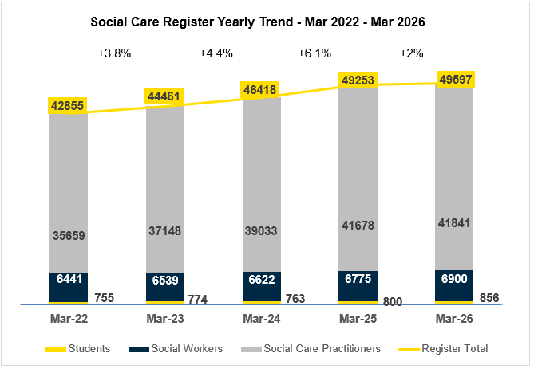
Key insights –
- Social Care Practitioners consistently account for the largest proportion of the workforce.
- Workforce numbers have increased across the three parts of the register.
- Social Workers are growing in number, but their proportional share is slightly decreasing.
- Social Work students show modest growth, indicating a stable future pipeline
- Workforce composition remains consistent over time with no major structural shifts.
- Overall trend reflects steady expansion with stable role distribution

2. Structure of the Register
Registrants identified themselves across 22 Job Roles (Sub-Parts of the Register) as shown below.
- Sub-Parts of Part 1 of the Register are Qualified Social Workers and Internationally Qualified Social Workers (Social Workers qualified outside of the UK)
- Sub-Parts of Part 2 of the Register are those in designated Social Care Worker roles covered by compulsory registration and also a number of non-mandatory roles agreed with the Council where employers have required their staff to register.
- The third part of the Register is for Social Work Students currently engaged in the Social Work Degree Programme.

In Table 1 below Social Care represents 84.36 % of the Register, the most significant groups of Social Care staff identified as Adult Residential Care Workers (35.17%) and Home Care Workers (30.88%). The next largest groups within Social Care are Supported Living Workers (7.15%) and Day Care Workers (4.96%). These are the mandatory registration groups for social care. These proportions remain in keeping to that observed in the previous quarters for 2025/26. However, the growth in the social care register since Qtr 4 Mar 2025, is mainly due to Adult Residential Care Workers (increased by 0.5%) and Supported Living Workers (increased by 2.3%) joining the register.

Table 1
 | Job Role | Live Count at 31 Mar 2026 | % of the Register
PART 1 | Social Worker | 6900 | 13.91%
 | Social Work Student | 856 | 1.73%
 | Social Care Practitioner | 41841 | 84.36%
PART 2 | Adult Residential Care Worker | 17444 | 35.17%
PART 2 | Home Care Worker | 15323 | 30.88%
PART 2 | Supported Living Worker | 3544 | 7.15%
PART 2 | Day Care Worker | 2461 | 4.96%
PART 2 | Residential Child Care Worker | 765 | 1.55%
PART 2 | Social Work Assistant | 513 | 1.03%
PART 2 | Home Care Manager | 513 | 1.03%
PART 2 | Youth and Family Support Worker | 488 | 0.98%
PART 2 | Outreach Worker | 283 | 0.57%
PART 2 | Residential Home Manager | 159 | 0.31%
PART 2 | Day Care Centre Manager | 115 | 0.23%
PART 2 | Personal Advisor | 55 | 0.11%
PART 2 | Advocacy Worker | 48 | 0.1%
PART 2 | Residential Family Centre Worker | 36 | 0.07%
PART 2 | Driver | 29 | 0.06%
PART 2 | Rehabilitation Officer for the Blind | 30 | 0.06%
PART 2 | Education Welfare Officer w/o SW Qual | 21 | 0.04%
PART 2 | Environmental Technical Officer | 10 | 0.02%
PART 2 | Education Welfare Officer Manager | 4 | 0.01%
The workforce profile shows a clear predominance of direct care roles, with Adult Residential Care Workers and Home Care Workers consistently representing the largest proportions across all years. Although both roles increase slightly in number, their proportional share declines over time, indicating overall workforce growth and a gradual diversification of roles.
Key insights –
- Adult residential care workers and home care workers represent the largest number of jobs although their proportional share is declining slightly.
- Overall workforce numbers are rising across most roles.
- Data shows a shift towards community based and specialist roles alongside traditional care provision.
- Smaller roles remain stable, contributing to a balanced workforce structure.
- Trends are gradual and consistent, suggesting planned workforce development rather than rapid change.

3. Employment

3.1 Employment by Sector

- The register is split into four key employment sectors, employment agency, private, voluntary and statutory (including Health and Social Care Trusts, Education, Justice and NDPBs).

- The register currently lists 510 employing organisations across all the sectors.

In table 2 below at 31 Mar 2026, employment sectors for Social Workers and Social Care Practitioners continue to show significant differences, as previously reported.
The majority of Social Workers are employed within the Statutory Sector i.e. Health and Social Care Trusts (74.43%). As observed in Figure 4b, an increase of 3.5% Social Workers is observed in the Health and Social Care Trusts, since Qtr 4 Mar 2025. This is mainly due to Social Work students now graduated and transferring to Part 1 of the Register and the decrease of Recruitment Agency contracts where Social Workers are now gainfully employed in permanent or temporary posts.

The majority of Social Care Practitioners are employed within the Non-Statutory Sector with the largest number employed within the Private Sector (44.53%). At the 31 Mar 2026, 20.75% are employed by Health and Social Care Trusts. There has been 0.35% growth in the number of Social Care Practitioners joining the register, since Qtr 4 Mar 2025, the majority of which are employed in the Private Sector.

A small percentage of registrants have ‘not given’ recorded against their employer sector. As well as requests to registrants to update their employment which may have changed in period, employing organisations have permission and are encouraged to update the employment part of the records for those registrants who were their employees at a point in time. Both these activities help to increase the accuracy of the employment profile of the register.

Table 2
Employment Sector | % of Social Workers | % of Social Care Practitioners
HSC Trust | 74.43 % | 20.75%
Private Sector | 1.67% | 44.53%
Voluntary Sector | 6.18% | 16.21%
Recruitment/Employment Agency | 0.38% | 12.21%
FE/HE Education | 3.78% | 0.07%
Government | 2.06% | <0.01%
Justice | 4.47% | 0.14%
Other | 1.2% | 0.04%
Regulation/Inspection | 0.74% | <0.01%
Self Employed | 1.22% | 0.01%
Unemployed | 1.97% | 0.08%

Figure 3a Figure 3b
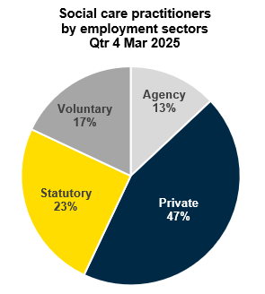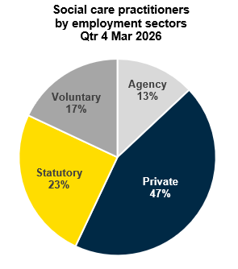
Figure 4a Figure 4b
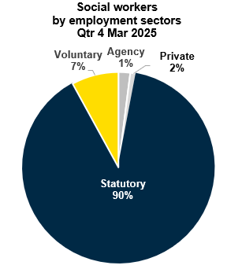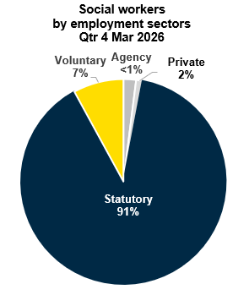
Between 31 Mar 23 and 31 Mar 26, the Social Work workforce became increasingly concentrated within HSC Trusts, with reduced agency reliance and lower unemployment. In contrast, the Social Care Practitioner workforce remained predominantly employed by private, voluntary and agency providers, with only modest changes in sector distribution. These trends point to improving stability within the Social Work profession while highlighting the continuing importance of the independent sector in delivering social care services.

Key insights -
- HSC Trusts strengthened their position as the principal employer of Social Workers, with representation increasing from 69.2% in March 2023 to 74.4% in March 2026 (+5.3%), indicating growing workforce concentration within statutory services.
- Agency employment among Social Workers fell significantly, decreasing from 2.3% to 0.4% over the four-year period, reflecting an 83% reduction, suggesting improved workforce stability and reduced reliance on temporary staffing arrangements.
- Social Care Practitioners remained predominantly employed in the independent sector, with the private (44.5%) and voluntary (16.2%) sectors accounting for over 60% of employment in 2026, highlighting the sector's dependence on non-statutory providers. Private sector employment grew for both professions, rising from 0.8% to 1.7% for Social Workers and from 40.8% to 44.5% for Social Care Practitioners, indicating continued expansion of independent sector provision.
- The employment models of the two professions remain markedly different, nearly three-quarters of Social Workers (74.4%) are employed by HSC Trusts, compared with only 20.8% of Social Care Practitioners, demonstrating the central role of statutory services for Social Workers and independent providers for Social Care Practitioners.

3.2 Social Workers – Employment by Work Focus
Social Worker ‘work focus’ provides an indication of the area of care and groups of people they provide services for as part of their job role. There are currently 30 different types of work focus recorded for Social Workers.
In Figure 5 below, analysis of Social Worker data for work focus shows that the greatest number of Social Workers (26.33%) work in services for Family & Child care, this includes Family Intervention and Looked After Children teams. The next largest work focus group (10.31%) are working in services for Older People.

Figure 5
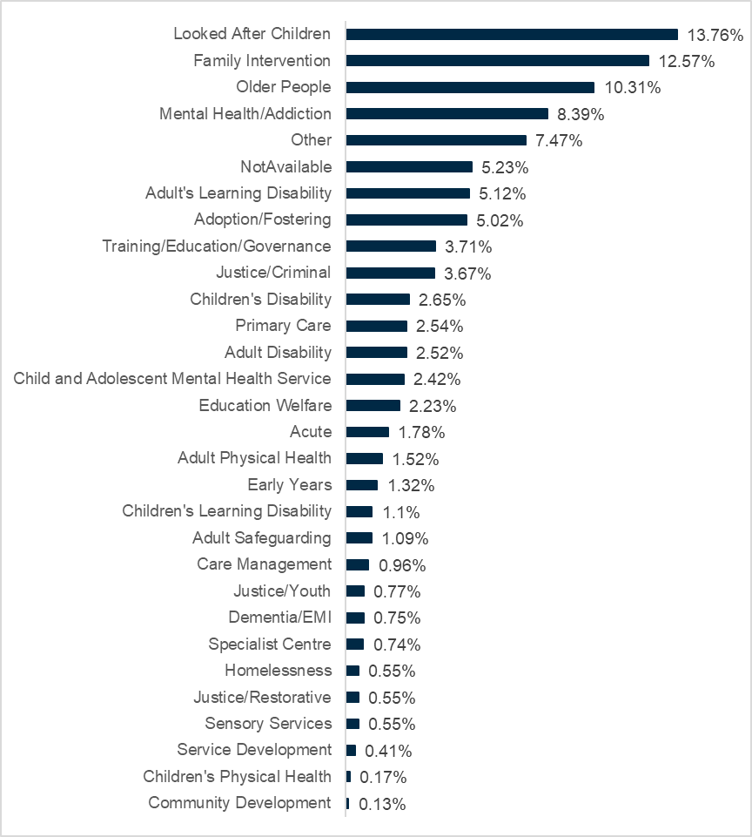
The workforce profile for Social Workers shows a progressive shift toward Children’s Services between Q4 2023 and Q4 2026, alongside a broadly stable but slightly redistributing pattern across other areas. Looked After Children demonstrates consistent yearly growth, becoming an increasingly prominent area of focus, supported by smaller increases in associated children’s services such as Children’s Disability. In contrast, Family Intervention shows a gradual decline, while Older People, Mental Health/Addiction, and most adult focused areas remain relatively stable, with only modest incremental changes. This indicates a continued core commitment to adult and health services, but with a clear strategic rebalancing toward children’s provision.
Key insights –
- Looked After Children is the fastest growing area, indicating increased emphasis on children’s services.
- Family Intervention shows a gradual decline, suggesting a shift in service mix.
- Adult and health-related services remain broadly stable, including mental health and older people.
- Small increases in support functions (e.g. training and governance) suggest strengthening infrastructure.
- Changes are incremental and consistent, reflecting planned workforce adjustment.
- Overall distribution shows a balanced profile with a clear shift toward children’s services.
- No sudden spikes in the data, suggesting a planned strategic shift.

3.3 Social Care Practitioners – Employment by Work Focus
Social Care Practitioner ‘work focus’ provides an indication of the area of care and groups of people they provide services for as part of their job role. There are currently 28 different types of work focus recorded for Social Care Practitioners.
In Figure 6 below analysis of Social Care Practitioner data for work focus shows that the greatest number of Social Care Practitioners (39.79%) work in services for Older People. The next largest work focus group (14.07%) are working in services for Adults with a Learning Disability.
These proportions of Social Care Practitioners’ work focus groups remain in keeping with reporting in previous quarters for 2025/26. However, the increase in the register from Qtr 4 Mar 2025 are mainly those social care registrants whose focus of employment is services to older people (increased by 3.3%) and adult learning disability (increased by 1.5%).
Figure 6
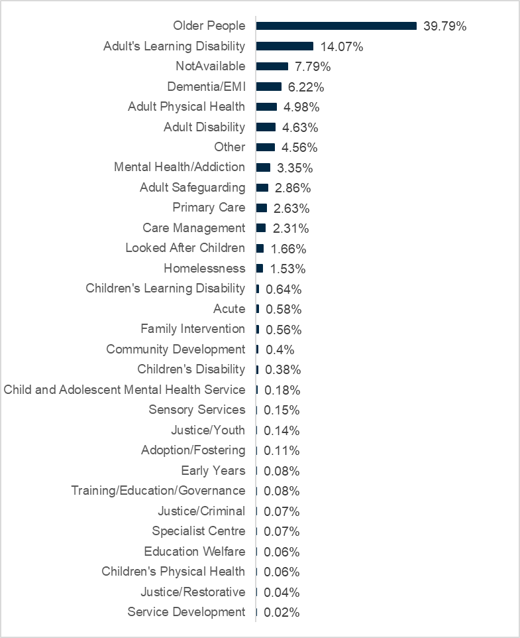
The workforce profile for Social Care Practitioners demonstrates a clear and sustained concentration in adult services, with this emphasis strengthening from Q4 2023 to Q4 2026. Older people services remains the dominant area of focus and continues to grow steadily, supported by increases in Adult Learning Disability, Mental Health/Addiction, and Adult Safeguarding, reflecting the ongoing demand associated with complex adult care needs. At the same time, there is evidence of minor rebalancing within adult services, with slight reductions in areas such as Primary Care and Adult Physical Health. Children’s services account for a much smaller proportion of workforce activity, although Looked After Children shows modest growth over time. Overall, the pattern indicates a stable but gradually evolving workforce distribution, with incremental changes aligned to shifting service demand rather than significant structural change.
Key insights –
- Older people services is the largest and fastest-growing area, reinforcing its central role in service delivery.
- Adult services dominate overall workforce focus.
- Some rebalancing within adult services, with small declines in primary care and physical health.
- Children’s services retain a smaller share, with modest growth in Looked After Children
- Changes are gradual and consistent, indicating a stable workforce responding to evolving demand.
- Overall distribution reflects a strong emphasis on adult care within a broadly balanced service model.

3.4 Social Workers – Engagement in the Professional in Practice (PiP) Framework for Social Worker CPD
Social Workers are required to complete 90 hours of Continuous Professional Development (CPD) during every three-year registration period. The PiP Framework provides certificated recognition of competence across the professional spectrum, providing a range of pathways to support Social Workers’ in meeting the requirements for their on-going learning and development. Currently, engagement in PiP activity is compulsory for newly qualified Social Workers who are required to complete PiP requirements within the professional Consolidation Award following completion of their Assessed Year in Employment. 56% of Social Workers on the live Register have achieved or are working towards awards within the PiP Framework to fulfil their CPD requirements.
Table 3
Award Status | Social Workers on the Live Register
1 Achieved Award | 39%
2 Waiting Award | <1%
3 In Progress | 16%
4 Withdrawn from Award | 26%
5 No PIP Engagement | 18%
PiP Engagement

Of those Social Workers on the Register who have completed Awards, 22% hold the NI Consolidation Award, 30% hold the NI Specialist Award and 3% hold the NI Leadership & Strategic Award. 4 Social Workers hold the PiP Advanced Scholarship Award.
The employment sectors for Social Workers holding awards are closely matched to the proportion of registered Social Workers employed in each of these sectors. 76% are employed in Health and Social Care Trusts, 6% are employed in the Voluntary Sector, 4% in Justice and 4% in Education.
4. Workforce Age and Gender
As reported in Figure 7b & 8b below for Qtr 4 Mar 2025, Social Work and Social Care show similar patterns in gender split, with 82% of the workforce identifying as female. Representation across the age bands remains steady, with 33% of Social Workers and 49% of Social Care Practitioners in the under 40 age bands. This proportion is in keeping with Qtr 4 Mar 2025.
Figure 7a Figure 7b
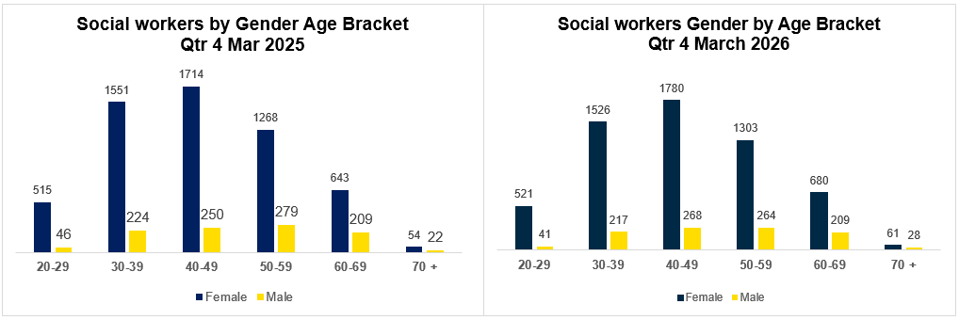
Figure 8a Figure 8b
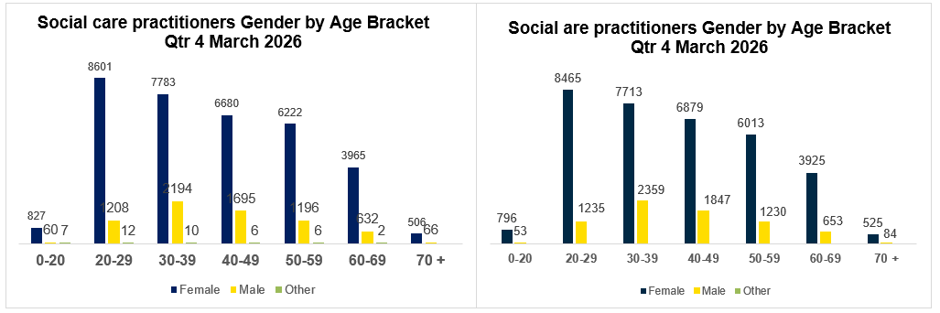
The data shows that the workforce is predominantly female across both Social Workers and Social Care Practitioners, with this pattern remaining consistent between March 2023 and March 2026. Female staff account for the clear majority in every age group and year, particularly within social care practitioners where they represent over four-fifths of the workforce. While male representation is significantly lower, it remains stable over time, with modest increases in some age groups, indicating limited but gradual diversification of the workforce.
Across both staff groups, the age profile highlights a concentration in mid-to-late career ranges, especially within the 30–59 age bands. There is steady growth in workforce numbers over time, with increases evident in most age categories, particularly among those aged 40–59. Older age groups (60+) also show gradual increases, suggesting a maturing workforce with rising retention in later career stages. In contrast, younger age groups represent a smaller share, although there is consistent entry at early career stages, supporting workforce continuity. Overall, the data indicates a stable and expanding workforce with a strong female majority and an experienced age profile.
Key insights –
- Workforce is predominantly female across all years and roles.
- Male representation remains stable, with slight increases in some age groups.
- Largest concentration is in ages 30–59, reflecting an experienced workforce.
- Growth in older age groups (60+), indicating extended workforce participation.
- Younger cohorts remain smaller but consistent, supporting future workforce supply.
- Overall trend shows a stable, growing, and experienced workforce profile.

5 Conclusion
In Quarter 3 (December 2025), the Register experienced a marginal increase of 0.2%, rising to 49,503. This was followed by a further incremental increase of 0.2% in Quarter 4 (March 2026), bringing the total to 49,597. Overall, growth has stabilised, with a modest annual increase of 0.7%.
This growth has been primarily driven by an increase in Social Care Practitioners working in adult residential care and supported living, with numbers rising by 0.4% over the year. In contrast, the number of home care workers declined slightly by 0.4%, which may reflect the broader stabilisation of register growth.
Encouragingly, the workforce continues to show a strong representation of younger professionals, with 47% of registrants under the age of 40.
Social Care remains the largest segment of the Register, with Adult Residential Care Workers and Home Care Workers representing the most prominent groups. Employment patterns remain consistent, with most Social Workers employed within the statutory sector (e.g. Health and Social Care Trusts), while Social Care Practitioners are distributed across multiple sectors, predominantly within the private sector, where the majority of newly registered Social Care Practitioners are employed.
In terms of practice focus, Social Workers continue to concentrate primarily on Family and Child Care services, highlighting their critical role in supporting vulnerable families and children. Services for Older People also remain a key area of focus. Similarly, Social Care Practitioners are largely engaged in services for Older People, followed by a significant proportion working with Adults with Learning Disabilities.
Engagement with the Professional in Practice (PiP) Framework for Continuous Professional Development remains strong, with many Social Workers participating in learning activities assessed against professional standards and, in many cases, aligned with academic quality benchmarks.
Overall, there have been no significant changes in registrant numbers, employment sectors, areas of practice, or gender distribution compared with Quarter 4 2024/2025 and Quarter 3 2025/2026. This indicates a stable professional landscape. These findings provide valuable insight into workforce trends and dynamics, supporting informed decision-making and effective resource allocation for stakeholders.
Author: Elizabeth Moore – Information Analytics & Intelligence Officer | Contact Details: Elizabeth.moore@niscc.hscni.net

5.2% of Social Workers have not specified their work focus as this level of detail was not required when Social Worker registration was first introduced. This information is being requested as Social Workers complete their 3-year renewal of registration or when they enrol in the Professional in Practice Framework (PiP) for their CPD.

